Colvend Lochs Aquatic Vegetation Survey 2025

Nick Stewart and Sarah White
April 2026

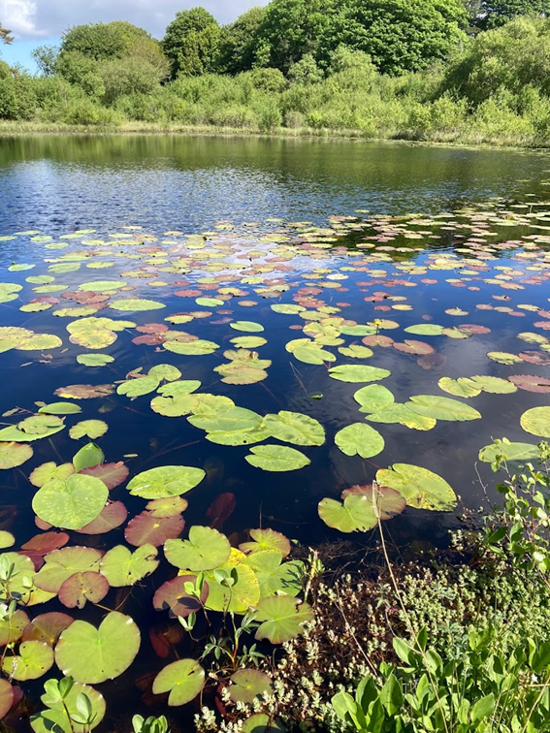
Black Loch

Summary
The lochs are a notable feature of the Colvend Parish landscape, in particular White Loch which forms a scenic backdrop to the main part of Colvend village.
There are six natural lochs in the parish and a significant number of man-made lochs and ponds.
Various recent and historic surveys have shown that these provide an important resource for wildlife including aquatic and wetland plants.
This survey was undertaken to assess the changes and threats to these lochs and to set a baseline to assess further changes in the future.
A total of 22 lochs and ponds were surveyed, mapping the main vegetation communities and recording the species present.
Various published references and data sources were investigated to gather historic information on the vegetation and history of the sites.
This survey was funded by a generous grant from the Royal Society of Edinburgh.
Landowners and those living adjacent to the lochs were approached for permission prior to the survey work, and without exception they showed enormous interest in and support for the project.
During the survey, a display of some of the plants found was organised at Colvend Community Hall and a talk was given about the project in the Community Hall as part of the Colvend series of winter lectures.
The survey has confirmed the importance of the lochs and ponds in the parish for plants. The water bodies were rather varied in character and many previously recorded species, including a number of species of local or county importance, were confirmed and several important new discoveries were made.
Notable aquatic species include: Needle Spike-rush Eleocharis acicularis, Delicate Stonewort Chara virgata, Floating Club-rush Eleogiton fluitans, Lesser Marshwort Helosciadium inundatum, Red Pondweed Potamogeton alpinus, Blunt-leaved Pondweed Potamogeton obtusifolius, Translucent Stonewort Nitella translucens, Dark Stonewort Nitella flexilis agg., Lesser Bladderwort Utricularia minor and Greater Bladderwort Utricularia vulgaris agg.
Notable emergent/marginal Species include Royal Fern Osmunda regalis, Great Fen-sedge Cladium mariscus, Bog Sedge Carex limosa, Lesser Tussock Sedge Carex diandra and Marsh St. John’s Wort Hypericum elodes.
Several invasive non-native species were encountered during the survey. Of particular concern was a population of New Zealand Pigmyweed Crassula helmsii discovered at White Loch.
Nutrient enrichment concerns were encountered at White Loch and to a lesser extent Drumstinchall Loch and Fairgirth Loch.
The highest nutrient site was Barend Loch but this loch was created to act as a natural diminution sink for a waste-water treatment system.
However, most sites showed no, or only limited, impacts from nutrient-enrichment.
Many sites have water with high levels of humic colouring which limited the depth range and extent of submerged vegetation. This is probably due to the acid geology (Criffel granite) but management activities in the catchment such as forestry activities could impact water colour in the future.
Although over half of the water bodies surveyed have been created within the last 100 years, there have been a significant number of others lost over the same period due to drainage or neglect.

Contents
Summary | 2
How the Project came about | 5
Introduction to the Colvend Lochs | 5
List of Sites Covered | 5
Historical Botanical Records | 7
Loch Name Changes | 8
Loch Age | 11
Survey Methodology | 11
Outputs | 13
Engagement | 13
Interpretation of Results | 14
Notable Species | 18
Non-native plants | 22
Further Work | 23
Acknowledgements | 23
References | 23
Appendices
Appendix 1: Statistics from the UK Lakes Portal | 25
Appendix 2: Sketch map and site notes for each loch (Alphabetical Order) | 26
Appendix 3: A composite species list for all sites | 66
Appendix 4: Comparison with historical records. | 74

How the Project came about
Simon Pain from the Colvend Community Council identified an opportunity to apply for a grant from the Royal Society of Edinburgh for a community-led award called ‘Healthy Planet Healthy People’. A joint application was submitted by the Colvend Community Council and the Botanical Society of Britain and Ireland (BSBI) with the aim of undertaking a vegetation survey of the Colvend Lochs. These lochs are a very significant feature of the landscape and living environment of the Colvend community and the aim of documenting their marginal and aquatic vegetation was both to provide information for the local community and to set a baseline against which any future changes could be measured.
We were lucky enough to be awarded £5,000 to cover the cost of employing a specialist aquatic plant surveyor, Nick Stewart, and some of the marginal vegetation was surveyed voluntarily by members of the Kirkcudbrightshire Botany Group (KBG).

Introduction to the Colvend Lochs
The lochs are a notable feature of the parish landscape, in particular White Loch which forms a scenic backdrop to the main part of Colvend village. The other main lochs, all nearby on the north side of the Dalbeattie Road nestled into depressions in the glacial till so that they are all but invisible from it, are Clonyard, Barean and Duff’s, while Black Loch lies to the south of the road between the Church and the Manse. In addition there are numerous smaller lochs and pools scattered throughout the parish and in total the survey covered 22 sites (map and list below).

List of sites covered
Auchenskeoch | Golf course 1
Barean | Golf course 2
Barend | Golf course 3
Black | Golf course 4
Clonyard Loch | Golf course 5
Clonyard pond | Jennifer's Pond
Duff’s | Newbarns
Dumstinchall | Pond opposite Clonyard
Dunmuck lower | Southwick House
Dunmuck upper | Southwick Lake
Fairgirth | White

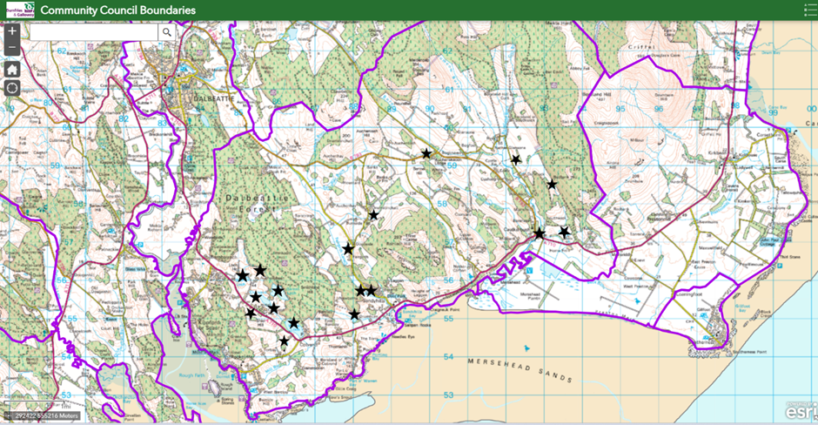

Historical Botanical Records
There are a number of sources of previous botanical records, listed in the References section below. Most comprehensive are the online national database maintained by the BSBI and the ‘Flowering Plants of Kirkcudbrightshire’ produced by Olga Stewart in 1990.
In the Nineteenth Century, James M’Andrew produced ‘A List of the Flowering Plants of Dumfriesshire and Kirkcudbrightshire’ (1882).
In terms of local records, we are particularly fortunate that the Rev. James Fraser (1814-1902), Minister of the United Parishes of Colvend and Southwick, was a very keen botanist who recorded plants and updated W R M’Diarmid’s Handbook of The United Parishes in a Second Edition in 1895. This contains a whole chapter on Botany which is written with both considerable botanical knowledge and great affection for the Parish. He says, for instance (p.60):
‘I was not long settled in Colvend until I found that it was peculiarly rich in botanical treasures. And the explanation is that Colvend contains within itself great and marked varieties of land and water…..
But what chiefly gives to Colvend its character botanically is its lochs and seashore…
At one time there were in Colvend some ten or eleven lochs…several of which have been drained….but there remain still six lochs undrained….. and in these are to be found all the ordinary and not a few of the rarer, lacustrine plants.’
James Fraser was also very involved with the Dumfriesshire and Galloway Natural History and Antiquarian Society (DGNHAS) and their transactions contain several of his papers. The Society made at least two summer excursions to Colvend, for example on 6th June 1865 when they examined Barean, Clonyard and White Lochs and listed the plants they found.
Fraser (1895) lists (p.63) plants found in the lochs, marshes and peat mosses of the Parish with comments on their location and abundance. Our survey results can be compared with this list (see Interpretation of Results section below).
Since Fraser’s time, there have been two national loch surveys:
The Bathymetrical Survey of Scottish Fresh-water Lochs, by Sir John Murray and Laurence Pullar 1897-1909, published in 1910. This study included botanical records by George West. Only the larger Colvend Lochs were described in this survey: Auchenhill (now known as Duff’s), Barean, Clonyard and White.
The Scottish Loch Survey 1996 was a project carried out by Scottish Natural Heritage (now NatureScot). For the larger Scottish lochs this was a very comprehensive survey but unfortunately, of our local lochs, they only covered White Loch.
An unexpected bonus were some previously unknown records from local botanist James Taylor of Drumskeoch which were kindly made available to us by Mary McGhee, his granddaughter. These included a range of fascinating records from across the Stewartry as well as local ones. Notable was his record for Shoreweed Littorella uniflora which he found ‘in abundance near the boulder bed’ at White Loch in July 1961, the first record since West’s of 1905.

Loch Name Changes
One complicating factor in comparing our survey results with older records has been the change of name of some of the lochs. James Fraser (1895) refers to Auchensheen, Barnhourie, Manse, Ironhash and Barscraigh Lochs, none of which appear on the current OS map. The 1854 OS map clarifies the situation in part: Barnhourie Loch is the old name for Newbarns, while Auchensheen is an old name for Duff’s Loch (see extracts from 1854 map below). It appears that Duff’s Loch was at one time also known as Auchenhill Loch: Murray and Pullar (1910) describe Auchenhill Loch as lying 4 miles south of Dalbeattie, the smallest of a group of four lochs. Moreover, half the loch frontage is still owned by Auchenhill. Auchensheen/Auchenhill had become Duff’s Loch by 1894 but why its name changed is unclear. The only local reference to Duff that we have come across is the Rev. James Duff who wrote the account of the parish of Colvend and Southwick in the Third Statistical Account of Scotland (Laird and Ramsay, 1965).

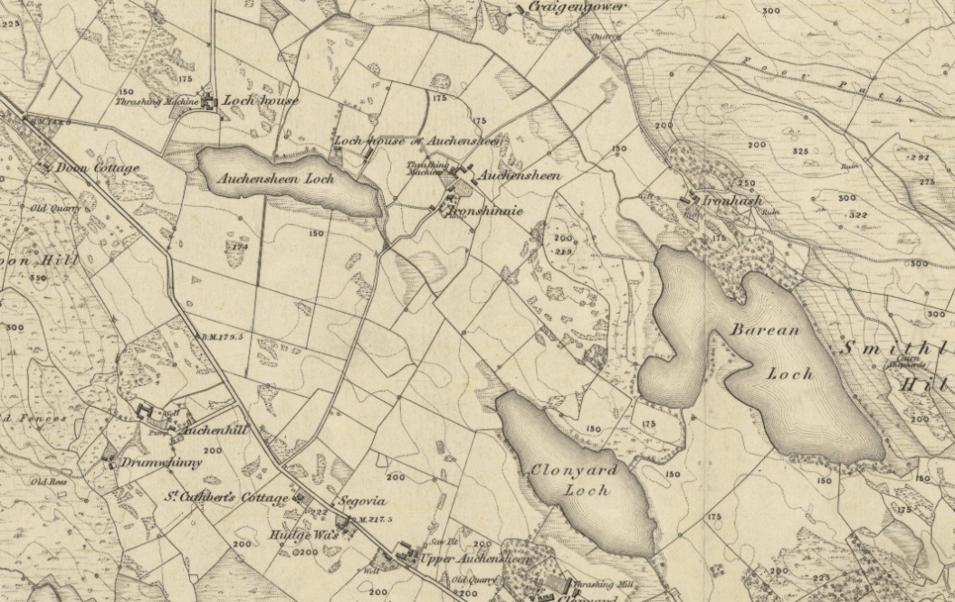
Extract from the 1854 OS map showing Duff’s Loch as Auchensheen
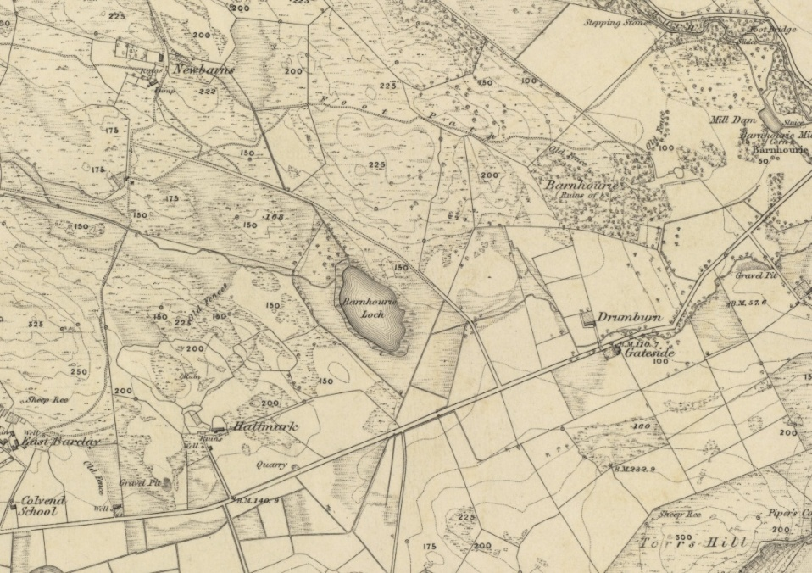
Extract from the 1854 OS map showing Newbarns Loch as Barnhourie.

The identity of ‘Manse Loch’ required more detective work. In his 1864 ‘Brief Account of the Botany of Colvend and Southwick’, James Fraser (1866) referred to ‘Manse Loch’ and the occurrence there of Lesser Bulrush Typha angustifolia, as well as the ‘near extirpation’ of Royal Fern Osmunda regalis from ‘Manse Loch’. In his later account (Fraser,1895), he refers to the loss of Royal Fern from ‘White Loch’. Since Lesser Bulrush is still a particularly distinctive feature of White Loch, but is rare elsewhere, it seems most likely from these references that Manse Loch must therefore be an old name for White Loch. Moreover, the Manse would have had a commanding view of White Loch before growth of trees obscured it.
This suspicion is confirmed in a paper by Peter Gray (1848) who says:
‘Down the middle of the Parish there extends a chain of five lochs….The one upon the roadside near the manse, styled the Manse or White Loch..’

Barscraigh Loch is believed to be the same as Cloak Loch and was sadly drained. It is marked on the 1854 map but by 1952 there is a drain running through it and today it is just a boggy area of ground.
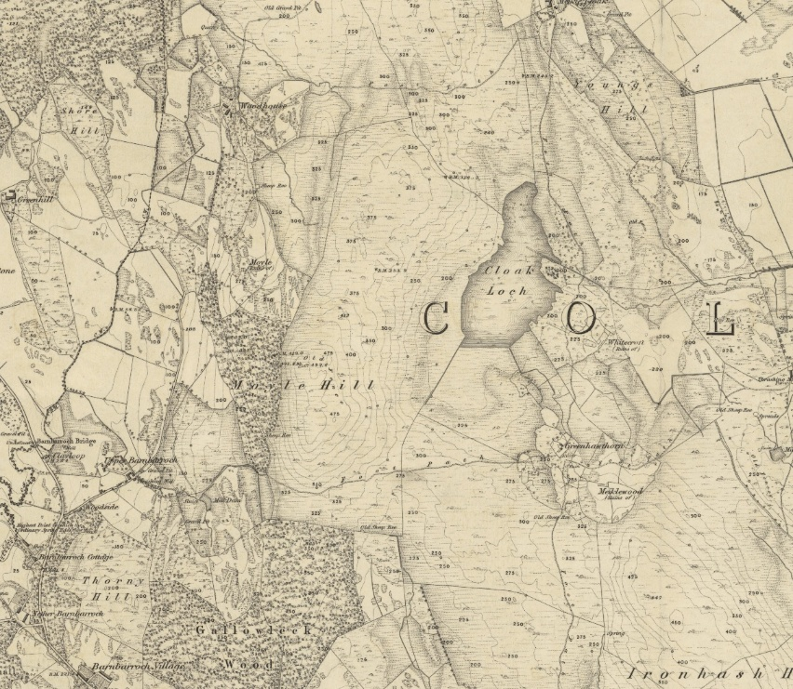
Extract from1854 OS map showing Cloak Loch
The name ‘Ironhash Loch’ remains a mystery but there was a settlement near Barean Loch called Ironhash, now overwhelmed by forestry. It seems that Barean was also known as ‘Barean and Ironhash Loch’ as an account of an 1882 field meeting in TDGNHAS refers to it as such (Anon, 1884). Moreover the loch has two lobes, the eastern of which is marked ‘Barean’ and the western lobe might have been known as ‘Ironhash’. See extract from 1854 map below.
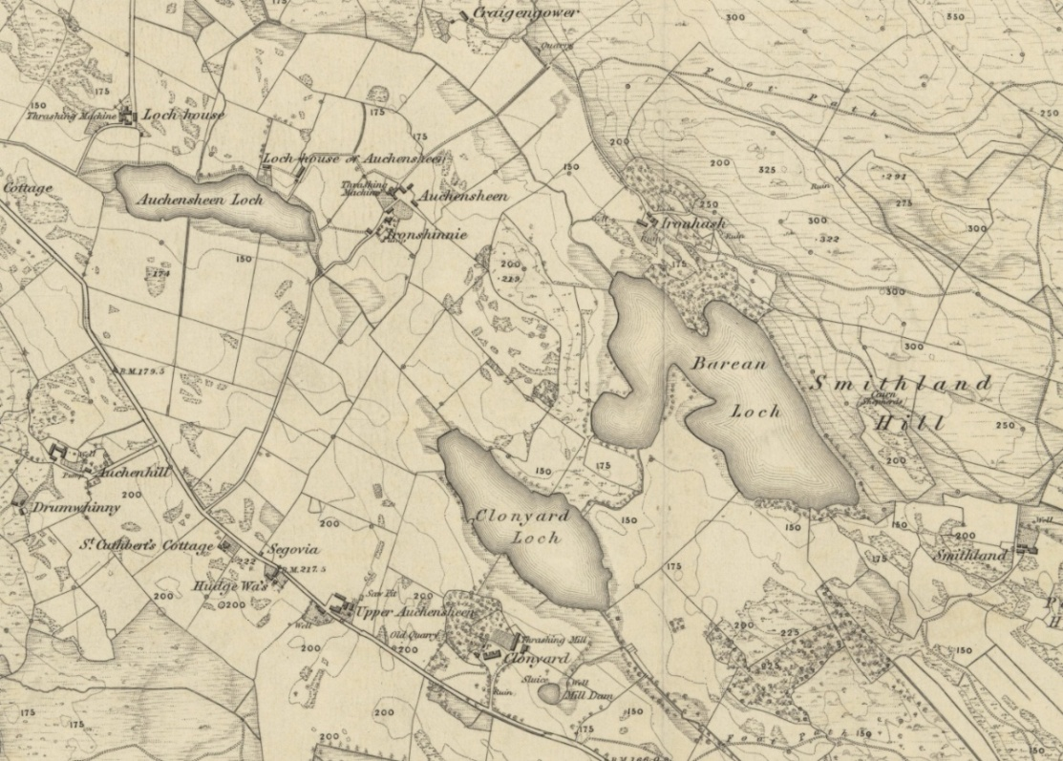
Extract from 1854 map showing the settlement of Ironhash outlined in red and the arrow showing the western lobe of Barean which may have been known as Ironhash Loch.

Fraser p.14 describes how ‘Most of the lochs have been more extensive than they are now, their dimensions having been reduced by drainage’. Shading around the edges of both Barean and Clonyard on the map above might indicate the previous extent of water.

Loch Age
Many of the sites surveyed are quite recent in origin; Drumstinchall Loch first appears on OS maps in 1950, Southwick and Auchenskeoch Lochs in 1957 and Southwick Garden Pond in 1967 (source: National Library of Scotland maps.www.nls.uk). Barend Loch and the two ponds at Dunmuck can be seen on aerial photographs in 1988 (National Collection of Aerial Photography www.ncap.org) while Fairgirth Loch, the Golf Course ponds, Jennifer’s Pond and the pond opposite Clonyard can be seen on aerial photographs in 2009 or later (Google Earth). On the other hand, Clonyard Upper Pond was already present in 1854 when it is shown as a water supply for a threshing mill at Clonyard Farm.
The Gull Loch (Strandside Dam) which was overgrown at the time of our survey was missing from the 1854 map but present in 1896. Barlay Loch and Garryhorn Loch near Fairgirth were both present in 1854 although Barlay is dry now and we were unable to visit Garryhorn because of landowner concerns about the safety of the swampy ground. Smithland Loch in the forestry above Barean was also present in 1854 but had very little open water at the time of our survey.

Survey Methodology
The aim was to survey ‘emergent’ and ‘marginal’ vegetation growing in the shallows and wet ground around the edge of each loch, as well as true aquatic species which grow in the water itself.
Standard methods for aquatic macrophyte monitoring surveys are set out in the JNCC Guidelines (JNCC, 2005 & 2015). This consists of four components: a strandline survey of plants uprooted and washed onto the tideline; a survey of marginal and emergent species, a ‘wader survey’ of the shallow littoral zone and a boat survey of species growing in the open water. The JNCC guidance suggests sampling up to four discrete 100m sections of shoreline considered representative of the lake using these survey techniques. However, on small sites like the Colvend lochs it is possible to undertake a survey of the whole shoreline and open water with the advantage of recording as far as possible a complete list of species. This is the survey method used in the Scottish Loch Survey in 1996 and we have followed this approach. We mapped the distribution of vegetation in each site and compiled a list of the species present. For each of the species we made an assessment of the relative abundance, estimated on the DAFOR scale. (D=dominant, A=abundant, F=frequent, O=occasional, R=rare.)
Fieldwork was carried out during various dates during the summer 2025 for the marginal and emergent vegetation; the aquatic plants were surveyed 20-25 September.
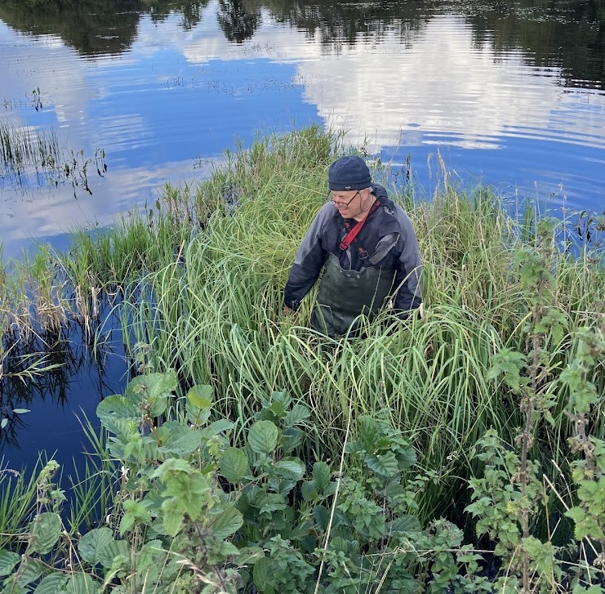
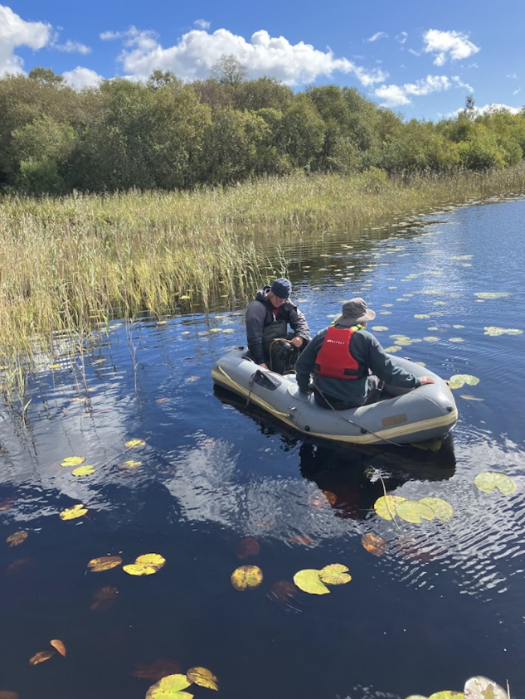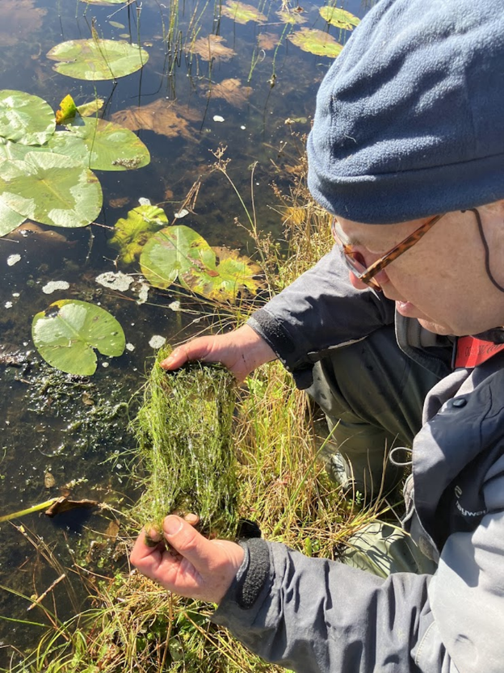

Outputs
The main output of the survey is a sketch map and species list for each of the 22 sites surveyed (Appendix 2)
A complete list of species recorded, which includes both emergent and aquatic species, is at Appendix 3.

Engagement
Landowners and those living adjacent to the lochs were approached for permission prior to the survey work, and without exception they showed enormous interest in and support for the project.
During the survey, a display of some of the plants found was organised at Colvend Community Hall and we were delighted that so many locals and visitors came along to have a look. See photo below.
Sarah White gave a talk about the project in the Community Hall as part of the Colvend series of winter lectures. It was well attended and well received.

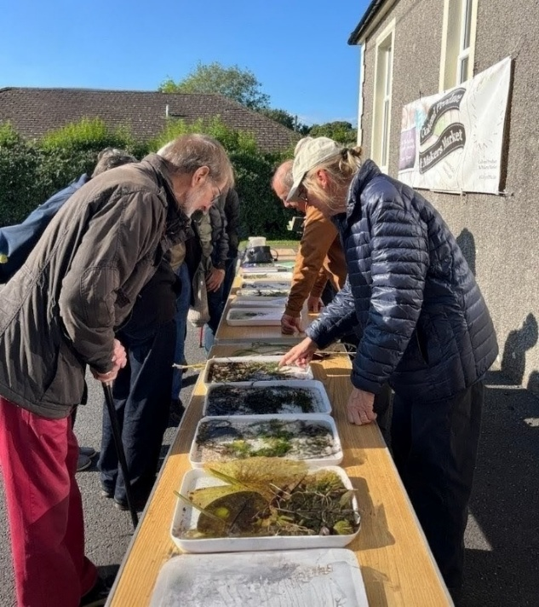 Photo: Theo Stanning

Interpretation of Results
Overview of the ponds and lochs in Colvend Parish
The sites surveyed included a considerable range of water body types. Only six of the sites are natural water bodies and only three of these are more than 4 hectares in extent. The rest have been formed from excavation, damming streams and embanking areas of flood plain. Their original/current uses include ornamental ponds, sporting lochs for fishing or wildfowling, livestock watering places, mill supplies, golf course hazards and wildlife enhancements. Barend loch was created to act as diminution for waste-water treatment before the water feeds into the adjacent stream.
The result is a very mixed character between the different water bodies. The natural lochs are probably formed in kettle holes or other depressions in glacial deposits. These are distributed to either side of the main road between Sandyhills and Barnbarroch. They may not be completely natural as there are some historic reports of water level changes (Fraser 1895). The smaller ones are surrounded by peat with areas of fen and wet woodland but the larger ones have more of a mixture of peaty and stony shores with a patchwork of fen, rush pasture, wet and dry woodland surrounding them. Areas of fringing swamp are common although limited by overshading trees in many places. Most have some sort of fringe of water lilies around the edge but all have strongly peat-stained water, and this restricts light penetration for submerged aquatic vegetation. This therefore tends to be restricted to where there are open shallows. Submerged aquatic species include Alternate Water Milfoil Myriophyllum alterniflorum, five species of Pondweed Potamogeton spp., three species of Stonewort Chara/Nitella spp. and two Bladderworts Utricularia spp.
Unlike the natural lochs which are all several metres deep, the manmade lochs and ponds are all shallow reaching up to 2 metres depth. As a result, they mostly have vegetation throughout. This often includes extensive swamp communities and, in some cases, such as Southwick Loch, these are now the predominant vegetation. Substrates vary between clay, silt and sand but peat substrates are rarer e.g Auchenskeoch Loch. This means that the aquatic vegetation tends to be more neutral in character including Broad-leaved Pondweed Potamogeton natans, Nuttall’s Waterweed Elodea nuttallii and Small Pondweed Potamogetonn berchtoldii, with Hornwort Ceratophyllum demersum being particularly abundant in Barend Loch and Willow Moss Fontinalis antipyretica in Drumstinchall Loch. The upper pond at Dunmuck is notable for several species not seen elsewhere, including Needle Spike-rush Eleocharis acicularis, Lesser Marshwort Helosciadium inundatum, Floating Club-rush Eleogiton fluitans and Water Crowfoot Ranunculus sp. Introduced aquatic species also play a significant role in some sites and this is discussed further below.
One of the biggest threats to aquatic plants across Scotland is from nutrient enrichment. This is often reflected in the vegetation in an increase in biomass, particularly in more nutrient tolerant species such as Nuttall’s Waterweed Elodea nuttallii, Hornwort Ceratophyllum demersum, Amphibious Bistort Persicaria amphibia, Willow Moss Fontinalis antipyretica and Duckweeds Lemna spp., together with a reduction in the diversity of more sensitive species. It is also commonly a cause of increased algal growth, either filamentous algae such as Cladophora or blooms of blue-green algae. In sufficient quantities the algae can suffocate the rooted aquatic vegetation and cause changes to the nature of the loch substrate.
Significant growths of filamentous algae were noted at Barend Loch, Fairgirth Loch, Southwick Loch and to a lesser extent Drumstinchall Loch and Golf Course Pond 3. A weak algal bloom was also noted in White Loch although this was more noticeable in sheltered and down-wind areas where there was more accumulation. A number of nutrient-sensitive species have also been lost from White Loch, including Shoreweed Littorella uniflora, Water Lobelia Lobelia dortmanna, Greater Bladderwort Utricularia vulgaris agg., Red Pondweed Potamogeton alpinus and Blunt-leaved Pondweed Potamogeton obtusifolius. Some blue-green algal bloom was also noted at Fairgirth Loch. At all of these sites measures to reduce nutrient inputs should be investigated. However, aside from these, in general, most of the lochs and ponds showed rather little evidence of enrichment. Although the surrounding catchments often contain significant areas of improved pasture where there are presumably regular applications of manure, these are broken up by woodland and more semi-natural ground and many sites have fringing fen or wet woodland which will absorb much of any nutrient run-off. Another source of nutrients can be from poorly maintained cess-pit and soakaway systems and this could be a source of nutrients at White Loch.
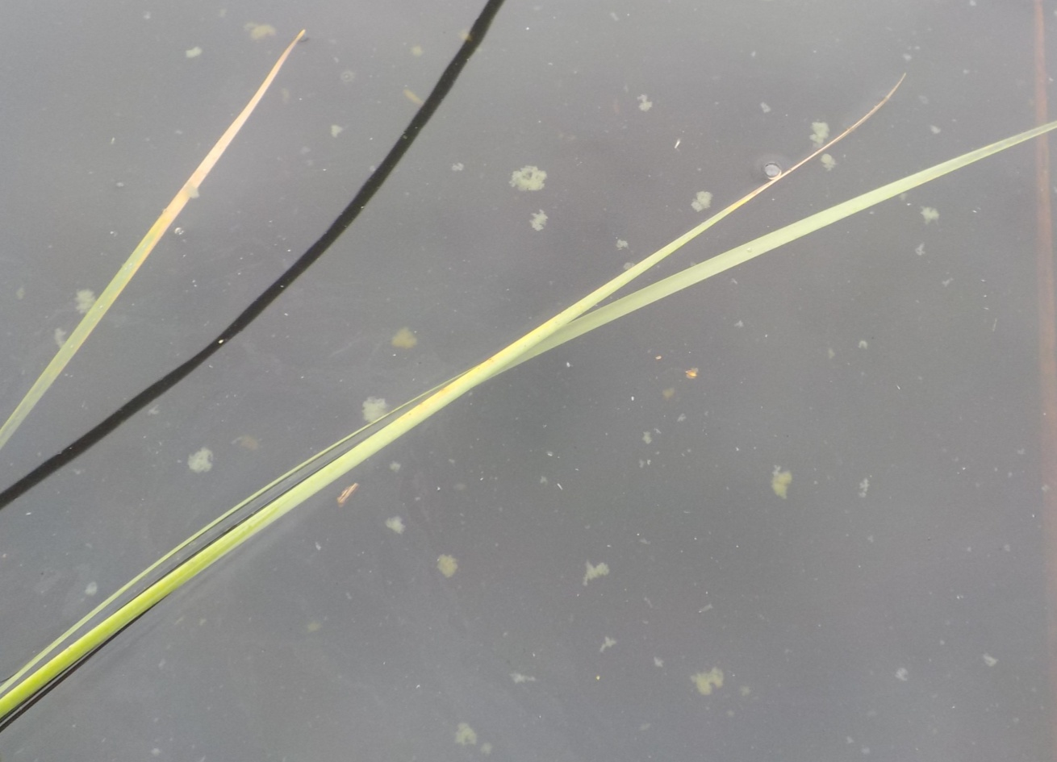
Clumps of blue-green algae floating on water surface, White Loch

A limiting factor on the aquatic vegetation at some sites is the high humic colouring of the water. This is likely a natural feature due to the acid nature of the Criffel granite which underlies most of the area. However, it can be exacerbated by cultivation on peaty soils and by run-off from forestry felling and replanting operations. This was not perceived to be an issue during the present survey but could become so if there are major management operations in Dalbeattie Forest.

Comparison with historical records. The historical aquatic plant records are generally confined to the larger lochs and so a meaningful comparison can only be made for these. Tables of past records are at Appendix 4. For the other smaller sites, our data sets a valuable baseline for any future survey work.
A table of some of the notable loch plants (both aquatic and marginal) listed by James Fraser (1895) together with their occurrence in 2025 is shown below. It is encouraging that all but two of the species that he mentioned were re-found in 2025. The two that were not re-found, Water Lobelia Lobelia dortmanna and Quillwort Isoetes lacustris, are marked in red.

List of Plants found in the Lochs of the Parish.
From: Handbook of the United Parishes of Colvend and Southwick 1895, by Rev James Fraser page 63
Common Name | Scientific Name | Location 1895 | Recent Record | 2025 Location
Slender Sedge | Carex filiformis  (assumed = C.lasiocarpa) | Barscraigh Loch | 2022  D. Hawker et al | Black Loch
Bog-sedge | Carex limosa | Barscraigh Loch | 2022 & 2025 | Black Loch
Whorled Caraway | Carum verticillatum  (=Trocdaris verticillata) | Plentiful in damp meadows | 2025
Great Fen-sedge | Cladium mariscus | Barnhourie Loch  = Newbarns | 2025 | Clonyard & Newbarns
Marsh St John’s-wort | Hypericum elodes | No locality given | 2025 | Newbarns Loch; Black Loch
Quillwort | Isoetes lacustris | White Loch and other lochs |  | Not re-found
Shoreweed | Littorella uniflora | White Loch | 2025 – single plant; flotsam | Barean Loch
Water Lobelia | Lobelia dortmanna | White Loch |  | Not re-found
Gypsywort | Lycopus europaeus | Marshy ground, Manse Loch (=White Loch?) | 2025
White Water-lily | Nymphaea alba | Plentiful in different lochs | 2025 | Duff’s Newbarns, Black, Barean.
Yellow Water-lily | Nuphar lutea | Plentiful in different lochs | 2025 | Duff’s, Black, Newbarns, Black, Barend, Barean, White.
Royal Fern | Osmunda regalis | Abundant shore of White Loch 50 years ago, now extirpated, | 2025 – single large plant | Colvend Lochs
Skullcap | Scutellaria galericulata | Sides of lochs | 2025 | Clonyard Loch
Lesser Bulrush | Typha angustifolia | White Loch | 2025 | White Loch
Greater Bladderwort | Utricularia vulgaris | Barscraigh Loch | 2025 | Barean Loch
Lesser Bladderwort | Utricularia minor | Barscraigh Loch | 2025 | Black Loch

It is still possible that the two missing species might be re-found. If they are only present in small quantity, they are more difficult to pick up. Quillwort is a plant which grows on the bottom of lochs and is most easily found when uprooted by stormy weather and washed up on the tideline. However, these are both members of a group of submerged spiky rosette species, sometimes referred to as “Isoetids”. It is notable that this group of plants are very poorly represented in the Colvend lochs with only a small amount of Shoreweed Littorella uniflora seen at Barean Loch. As bottom-growing species they are limited by light penetration which is restricted by the high colouring of the water at many sites. At White Loch the extension of swamp communities has probably also reduced the availability of suitable habitats but there are also concerns about nutrient enrichment here.
While Fraser’s data included some comments about abundance, in general the historical data does not. It is possible therefore that, even though the species are still present, there have been changes in abundance.

Notable Species
The Colvend lochs and ponds are of significant local importance for their aquatic and wetland plants. This is confimed by the number of notable plant species found during the Colvend Lochs Survey:
Notable Aquatic Species
Needle Spike-rush Eleocharis acicularis
Found in Dunmuck Upper Pond. Very rare Kirkcudbrightshire. In this area only previously recorded from Southwick Loch in 1982 but the habitat is no longer suitable there.

Delicate Stonewort Chara virgata
Found in Barean Loch. Occasional in Kirkcudbrightshire. Not previously recorded from the Colvend area, although there are records from Mabie Forest and lochs near Beeswing and Crocketford.

Floating Club-rush Eleogiton fluitans
Found in Dunmuck Upper Pond. Occasional in Kirkcudbrightshire and not known previously nearer than Dumfries and Rascarrel.

Lesser Marshwort Helosciadium inundatum
Found in Dunmuck Upper Pond. Occasional in Kirkcudbrightshire

Red Pondweed Potamogeton alpinus
Rare in Kirkcudbrightshire, Long known in White Loch but it was last seen there in 1970. It occurs in Clonyard and Barean Lochs. Its nearest other sites are near Haugh of Urr.

Blunt-leaved Pondweed Potamogeton obtusifolius
Occasional in Kirkcudbrightshire. Recorded in several sites on this survey but not refound at Drumstinchall where it was last seen in 1974 and White Loch where last seen in 1970. The exact location of a record from Barscraigh in 1992 is not known.
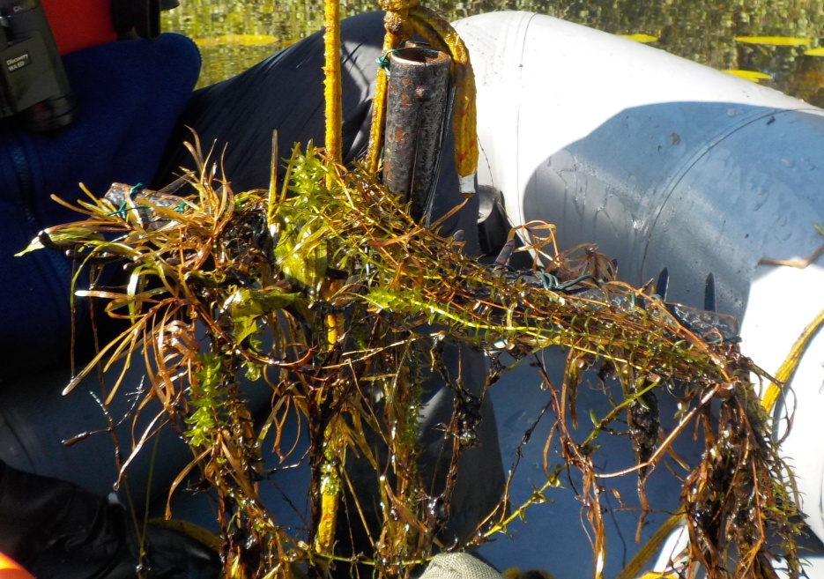
Blunt-leaved Pondweed Barean Loch

Translucent Stonewort Nitella translucens
Only recorded from eight sites in Kirkcudbrightshire but in the last 25 years it has only been seen here in Barean Loch and at Loch Kindar near New Abbey.

Dark Stonewort Nitella flexilis agg
Occasional in Kirkcudbrightshire. Still surviving in Southwick Loch where it was seen in 1994. Also in Barean Loch, Clonyard Loch and Clonyard Pond.

Lesser Bladderwort Utricularia minor
Occasional in Kirkcudbrightshire and rare in the east. It has long been known from the Colvend area where Fraser (1885) reported it from Barscraigh Loch. It grows in Black Loch and another site in Dalbeattie Forest as well as a pond on Southerness Links.

Greater Bladderwort Utricularia vulgaris agg
Occasional in Kirkcudbrightshire and rare in the east. It has long been known from the Colvend area where Fraser (1885) reported it from Barscraigh Loch. It grows in Barean Loch but it was not refound in White Loch where it was seen in 1996.

Notable Emergent/Marginal Species
Royal Fern Osmunda regalis
James Fraser (1895) referred to the ‘extirpation’ of Royal Fern from White Loch where previously it had been ‘abundant’. The first record for this plant in Kirkcudbrightshire was at Lot’s Wife Southwick in 1843 but there have been no records in the Colvend area since 1895. One likely reason for its loss is the Victorian fern craze which saw widespread collection of ferns from the wild for planting in gardens and conservatories which coincided with easier access to the countryside through the rail network. We were therefore delighted to find a single, large plant of Royal Fern during our survey.

Great Fen-sedge Cladium mariscus
This too was mentioned by James Fraser as one of the special plants of the Colvend Lochs which he recorded at ‘Barnhourie’ Loch now known as Newbarns Loch. Surprisingly Fraser didn’t mention its occurrence at Clonyard Loch where there is a bigger population than at Newbarns. It would seem that it wasn’t recorded at Clonyard until 1983. Our survey reaffirmed the presence of the plant at both sites.
Great Fen-sedge is a scarce plant in Kirkcudbrightshire, occurring at just one other site besides the Colvend Lochs. It is more typical of the Norfolk Fenland where it was used for thatching. Its other name is ‘Saw Sedge’ as it has an extremely rough edge to the leaf and requires careful handling.

Bog Sedge Carex limosa
Fraser (1895) states that this sedge was rare but occurred in great abundance at the foot of Barscraigh Loch (Cloak Loch), now drained. Fortunately, it still grows at Black Loch where we re-found it during our survey. This is the only site in Kirkcudbrightshire for this special sedge.

Lesser Tussock Sedge Carex diandra
This species is occasional in Kirkcudbrightshire but rare in the east. In this area it occurs at Black Loch and an area of fen by Auchenlosh Hill but otherwise in the eastern part of the county it is only known on the Almorness headland and near Cargenbridge.

Marsh St. John’s Wort Hypericum elodes
Another species that is occasional in Kirkcudbrightshire but rare in the east. Fraser (1895) mentions it without giving a locality but on this survey it was seen at Black Loch, Barean Loch, Newbarns Loch and on Colvend Golf Course.
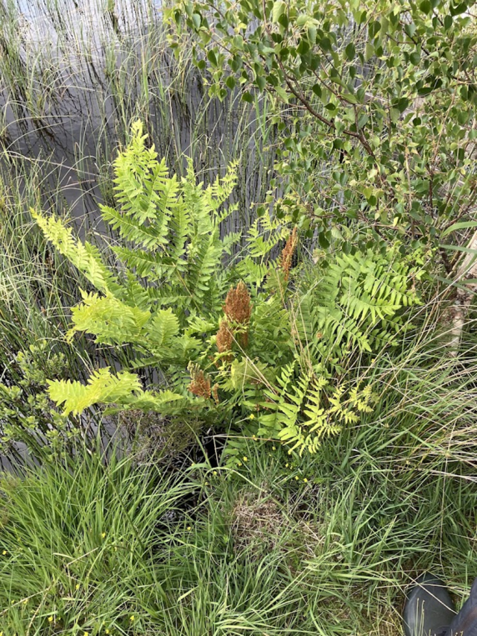 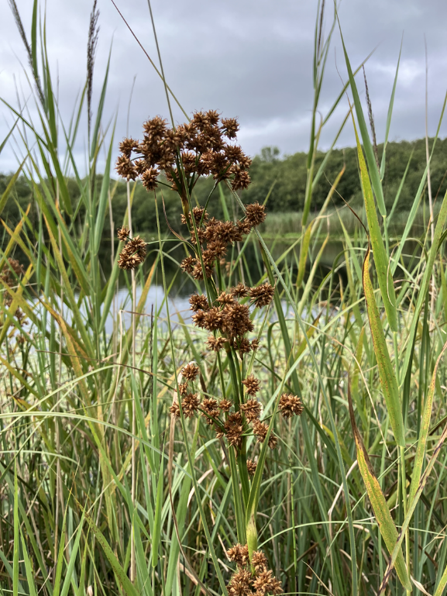 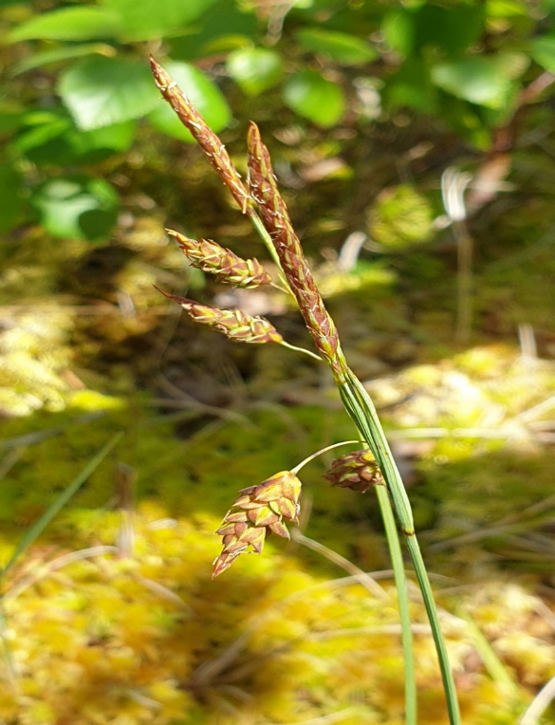 Royal Fern, Great Fen-sedge and Bog Sedge
Non-Native Plants
A number of non-native aquatic plants were recorded. This is not surprising as over half the recorded British flora now comprises non-native species.
A native plant is one that arrived naturally in Britain since the end of the last glaciation without the assistance of humans, or in rare cases, persisted during the last ice age. A plant introduced by human intervention, either deliberately or by accident, is described as non-native.
Many non-native plants cause no problems and make an attractive addition to our flora. However, non-native plants that spread aggressively (described as invasive) can do environmental harm by out-competing native species. Some of these were introduced as garden ornamentals and escaped into the wild where the lack of natural predators mean they can spread out of control.
Some of the non-native aquatic plants recorded in our survey are listed below together with comments on their location and any treatment required.
Frogbit Hydrocharis morsus ranae. Present in White Loch. Native in parts of England but not in Scotland. Doesn’t appear to be a problem at current levels.
Canadian Waterweed Elodea canadensis and Nutall’s Waterweed E. nuttallii. Both present at a number of sites. E. nutallii is especially dominant at Fairgirth and Auchenskeoch and abundant at Barend. Although both are invasive species, they are widespread in the county and control would be impossible. It is possible that the acid nature of some of the sites limits their invasiveness.
American Skunk Cabbage Lysichiton americanus This occurs in some of the gardens on the east side of White Loch and complete removal of plants is desirable to avoid spread.
Fringed Water-lily Nymphoides peltata Present at Southwick House and Auchenskeoch Loch, both presumed deliberately introduced as garden plants and therefore no action recommended.
New Zealand Pigmyweed Crassula helmsii Present on the east side of White Loch. Currently the area affected is limited but urgent specialist treatment to control it is required.
Cape-pondweed Aponogeton distachyos Present at Dunmuck. Not believed to spread to other sites without human assistance. No action recommended.
Least Duckweed Lemna minuta Only found at Barend. A tiny plant which would be impossible to control and not causing a problem.
Japanese Knotweed Reynoutria japonica Only found at Drumstinchall. An invasive plant which should be controlled.
The three species requiring control are Japanese Knotweed, American Skunk Cabbage and New Zealand Pigmyweed. The latter requires a specialist contractor.

Further Work
Urgent follow-up work is needed to:
- Control invasive species as recommended above
In the longer term we aim to:
- Research in more detail the history of the water bodies in the Community Council area, both as wildlife habitats and as features in our cultural landscape
- Add information about other taxa that are part of the loch habitat, such as invertebrates and birds
- Identify sources of nutrient enrichment which might be limiting wildlife interest and seek to address any problems
- Identify opportunities for enhancement where the wildlife value is adversely impacted by excess marginal swamp growth, shading or overgrazing
- Engage further with residents, visitors and stakeholders to ensure the lochs are valued and protected for the future
- Make use of this baseline survey to monitor changes

Acknowledgements
- The Royal Society of Edinburgh for generously providing grant aid for this project
- All the local landowners surrounding the lochs who were so welcoming and helpful
- The Colvend Community Council and BSBI for sponsoring the project
- Jim McCleary for his time and expertise in helping to carry out this survey

References
Anon. (1884). Field Meetings (1882) Colvend. Transactions of the Dumfriesshire and Galloway Natural History and Antiquarian Society Series II, 3 (1880-83), p71
BSBI database: https://docs.bsbi.org/ddb
BSBI Plant Atlas: https://plantatlas2020.org/atlas/
Fraser, Rev. J., (1895). Second edition of the Handbook of the United Parishes of Colvend and Southwick by W.R. M’Diarmid.
Fraser, Rev. J. (1866) Brief Account of the Botany of Colvend and Southwick. Transactions of the Dumfriesshire and Galloway Natural History and Antiquarian Society 1863-4 p.65
Giaquinto, F. & O’Brien, P. (2025) Non-Native Invasive Plants of Britain and Ireland. Pelagic.
Gray, P. (1848) Notes of a Cursory Examination of the Botany of Colvend, Kirkcudbrightshire, September 1848. The Phytologist vol 3 p.348-355
Joint Nature Conservation Committee (JNCC). 2015. Common Standards Monitoring Guidance for Freshwater Lakes (Version March 2015). Interagency Freshwater Group Report, JNCC, Peterborough. An electronic version of this report is available at: http://jncc.defra.gov.uk/pdf/0315_CSM_Freshwater_lakes.pdf
Joint Nature Conservation Committee (JNCC) 2005. Common Standards Monitoring Guidance for Freshwater Habitats and Species (Standing Water), 1st version. ISSN 1743-8160 (Online). Available online at http://jncc.defra.gov.uk/page-2232
Laird, J. and D.G. Ramsay eds (1965) The Third Statistical Account of Scotland: The Stewartry of Kirkcudbright, Collins.
M’Andrew, J. (1882) A List of the Flowering Plants of Dumfriesshire and Kirkcudbrightshire compiled for the Dumfriesshire and Galloway Natural History and Antiquarian Society.
Murray, Sir J. & Pullar, L. (1910) Bathymetric Survey of the Scottish Fresh-water Lochs.
Scottish Natural Heritage (1996) Scottish Loch Survey Dumfries & Galloway Area.
Stewart, O. (1990) Flowering Plants of Kirkcudbrightshire. Transactions of the Dumfriesshire and Galloway Natural History and Antiquarian Society Series III vol LXV
West, G. (1910) A Further Contribution to a Comparative Study of the Dominant Phanerogamic and Higher Cryptogamic flora of Aquatic Habit in Scottish Lakes. Proc. Roy. Soc. Edinburgh Vol XXX Pt. II (No.6) 65-181

Appendix 1: Statistics from the UK Lakes Portal

 | Area (ha) | Depth (m) | Catchment area (ha) | Altitude (m)
Barean | 9 | 11 | 263 | 48
Clonyard | 4 | 8.5 | 39 | 44
White | 13 | 13.5 | 412 | 37
Duffs | 1 | 3.7 | 77 | 45
Newbarns | 1 | 3.5 | 106 | 37
Barend | 2 | 3.5 | 1333 | 21
Drumstinchall | 1 | 3.8 | 48 | 103
Southwick | 1 | 3.4 | 155 | 13

https://uklakes.ceh.ac.uk/search.html

Appendix 2 : Sketch Map and site notes for each loch (Alphabetical Order)

Auchenskeoch Loch
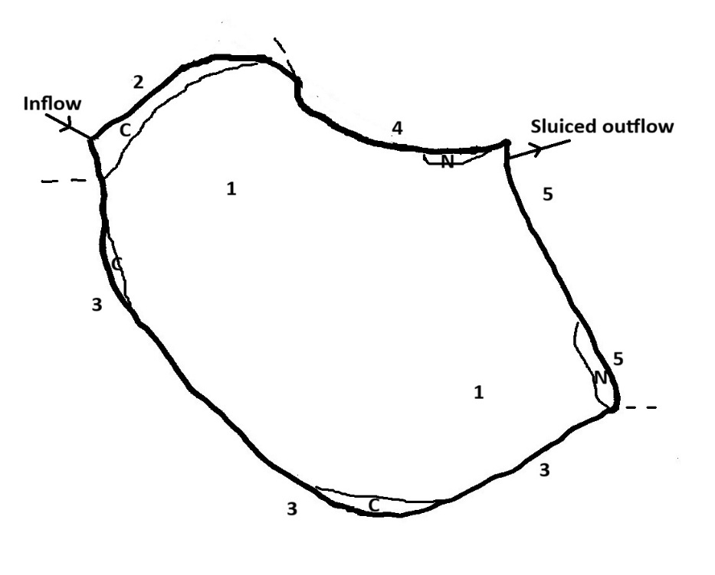
A small artificial loch formed by damming the Auchenskeoch Burn sometime in the 1950s. It is surrounded by woodland and much of the edge is overhung by willows. The only more open shore is along the north side where there is a narrow strip of coarse grass and fen. The water is dominated by Nuttall’s Waterweed Elodea nuttallii with several patches of Fringed Water Lily Nymphoides peltata around the edge. The water is very clear, but tea-coloured and the depth is estimated to be up to 1.5 metres.
1 – Nuttall’s Waterweed Elodea nuttallii dominant all across and right into the edges.
N – Patches of Fringed Water Lily Nymphoides peltata
C – Patches of Bottle Sedge Carex rostrata swamp.
2 - Soft wet woodland with patches of Rhododenron Rhododendron ponticum. Reed Canary Grass Phalaris arundinacea frequent at edge at back of Bottle Sedge Carex rostrata swamp.
3 – Closely enclosed by willows, overhanging the loch edge. Ground flora of grasses and ferns.
4 – Edge more open and narrow strip with rushy bits with Reed Canary Grass Phalaris arundinacea at the edge. Some willows.
5 – Embankment. Coarse grass and Meadowsweet Filipendula ulmaria with some small willows.
Comments: The aquatic vegetation is strongly dominated by non-native species with poor diversity. The overshading willows also limit the development of marginal species apart from a shallower area by the inflow.

Barean Loch
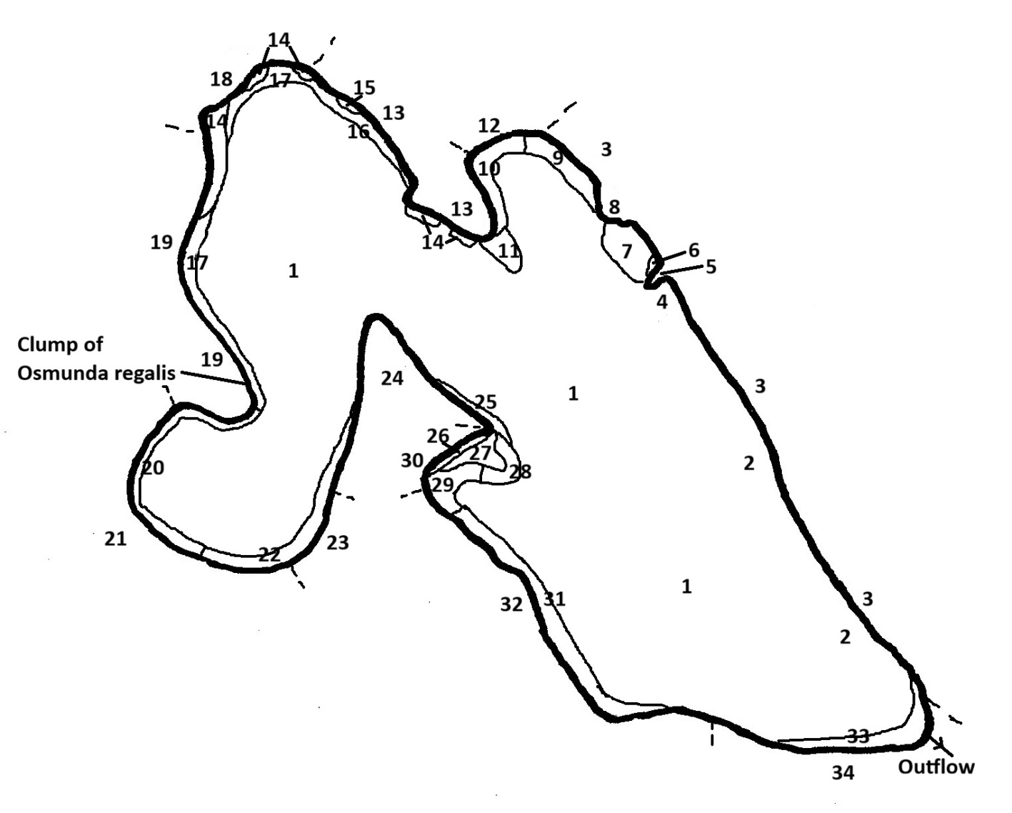
Barean is one of the largest of the Colvend lochs, second only to White Loch in area. Depths of 7 metres deep were noted on this survey but it is believed to reach 11 metres in some places. The water is tea-coloured with a secchi depth of 1.6 metres. The loch is largely surrounded by willows, alder and other trees which often overhang the edge, shading over the shallows. Beneath this are areas where the shores are quite steep and stony, particularly on the east side, and areas where there is peat lip up to grassy fen carr, such as on the north shore. There is grazing access to a substantial part of the south-west side. Here there is a thin line of trees with frequent gaps then rushy pasture along the lower parts of the fields. This is also more or less the only area where there are unshaded shallows.
There is a band of water lilies (Yellow Water Lily Nuphar lutea and White Water Lily Nymphaea alba) around much of loch, sometimes up to 20 metres wide. This varies in density and in some parts, where the bottom shelves fairly steeply, the fringing willows shade out over what would have been the water lily zone. In many areas there is little other aquatic vegetation apart from the water lilies but in the sheltered bays and in the more open shallows on the south-western side there are a good range of other aquatics, including four species of pondweed Potamogeton, three stoneworts and bladderwort. In these bays there are also intermittent areas of swamp communities, particularly Common Reed Phragmites australis, Common Club-rush Schoenoplectus lacustris, Bottle Sedge Carex rostrata and Bogbean Menyanthes trifoliata.
1 - Deep water, unvegetated.
2 – Bottom steeply shelving, stony in shallows and overhung by trees. No aquatic vegetation.
3 – Steepish bank up to track. Willows and alders overhanging loch edge.
4 – Bay with frequent Common Bladderwort Utricularia vulgaris agg., some Yellow Water Lily Nuphar lutea, and Canadian Waterweed Elodea canadensis. Also Delicate Stonewort Chara virgata and Red Pondweed Potamogeton alpinus.
5 – Low-lying headland. Common Reed Phragmites australis, Bottle Sedge Carex rostrata, with some Bogbean Menyanthes trifoliata and small alders.
6 – Patch of Bogbean Menyanthes trifoliata.
7 – Shallow bay with Yellow Water Lily Nuphar lutea, Delicate Stonewort Chara virgata and Common Bladderwort Utricularia vulgaris agg. Shore with fringe of Bottle Sedge Carex rostrata, Common Reed Phragmites australis and Common Club-rush Schoenoplectus lacustris.
8 – Small headland with fringe of Bottle Sedge Carex rostrata, Common Reed Phragmites australis to 3 metres wide
9 – Sparse Yellow Water Lily Nuphar lutea with locally frequent underwater form of Common Club-rush Schoenoplectus lacustris
10 – Yellow Water Lily Nuphar lutea
11 – White Water Lily Nymphaea alba patch extending out from headland
12 – Trees overhanging loch edge with Reed Canary Grass Phalaris arundinacea swamp beneath, or areas with shorter grass.
13 – Trees overhanging edge. Fairly steep bank with peat and stones.
14 – Patches of Common Reed Phragmites australis swamp.
15 – Common Club-rush Schoenoplectus lacustris patch.
16 – Patchy Yellow Water Lily Nuphar lutea and White Water Lily Nymphaea alba with locally frequent Common Bladderwort Utricularia vulgaris agg.
17 – Sparse Yellow Water Lily Nuphar lutea and White Water Lily Nymphaea alba. Some underwater form of Common Club-rush Schoenoplectus lacustris in the shallows and a little Bur-reed Sparganium sp. but remarkably little otherwise.
18 – Backed by wet willow carr swamp. Intermittent swamp patches at margin to 4 metres wide. Common Reed Phragmites australis, Common Club-rush Schoenoplectus lacustris and some Bottle Sedge Carex rostrata. Several inlets of floating fen at edge with Bottle Sedge Carex rostrata, Marsh St. John’s Wort Hypericum elodes, Marsh Cinquefoil Comarum palustre.
19 – Overhanging trees. Sometimes swamp beneath or sometimes 50 cm lip to grass and ferns beneath. One clump of Royal Fern Osmunda regalis.
20 – Fairly continuous Yellow and White Water Lily Nuphar lutea and Nymphaea alba band. Little of other species because shallower zones overshaded.
21 – Trees overhanging loch edge. Mostly just stony bank or grassy lip.
22 – Yellow Water Lily Nuphar lutea with a little Canadian Waterweed Elodea canadensis and Common Bladderwort Utricularia vulgaris agg.
23 – Livestock have access to the shore. There is a thin line of trees at the edge with grass or sometimes stony beneath
24 – Ungrazed. Willows overhanging loch edge. Some Yellow Water Lily Nuphar lutea tucked in the edge of the willow shade.
25 – Scattered Yellow Water Lily Nuphar lutea. A little Translucent Stonewort Nitella translucens but rare.
26 – Fringe of Bottle Sedge Carex rostrata, Common Reed Phragmites australis and Common Club-rush Schoenoplectus lacustris
27 – Large patch of Bogbean Menyanthes trifoliata
28 – Broad band of mixed Yellow Water Lily Nuphar lutea and White Water Lily Nymphaea alba.
29 – Yellow Water Lily Nuphar lutea with submerged Potamogeton alpinus, Blunt-leaved Pondweed Potamogeton obtusifolius, Canadian Waterweed Elodea canadensis, Translucent Stonewort Nitella translucens and Dark Stonewort Nitella flexilis agg.
30 – Wet woodland with willows overhanging the back of the swamp margin (see 26). Ungrazed
31 – Yellow Water Lily Nuphar lutea band. Where the shallows are less shaded there is a band between the shore and the water lilies with frequent Bladderwort Utricularia vulgaris agg, and some Dark Stonewort Nitella flexilis agg., Canadian Waterweed Elodea canadensis and Translucent Stonewort Nitella translucens.
32 – Edge open to grazing. There is a thin but gappy band of trees at the edge and rush pasture occupying much the lower parts of the fields. The shore is a mix of rush pasture, stony areas and grassy areas under shade.
33 – Area of Yellow Water Lily Nuphar lutea, not investigated on this survey.
34 – Wet woodland associated with outflow. Not investigated on this survey.
Comments: This site has a diverse aquatic flora, including a number of local species (e.g. Utricularia vulgaris agg., Translucent Stonewort Nitella translucens, Dark Stonewort Nitella flexilis agg., Red Pondweed Potamogeton alpinus and Blunt-leaved Pondweed Potamogeton obtusifolius). This diversity is mainly restricted to sheltered bays and the south-eastern shore. The presence of a clump of Royal Fern Osmunda regalis on the shore is also significant.
There is no indication of nutrient enrichment at this site. Much of the catchment is forestry, so there is a risk of silt inwash when major felling operations undertaken. There is some of the non-native Elodea canadensis present but this is not in significant amounts enough to affect the natural vegetation. There is no evidence that it is increasing, perhaps because of the low pH and nutrient status of the site, but this may need to be kept under review.
Barend Loch
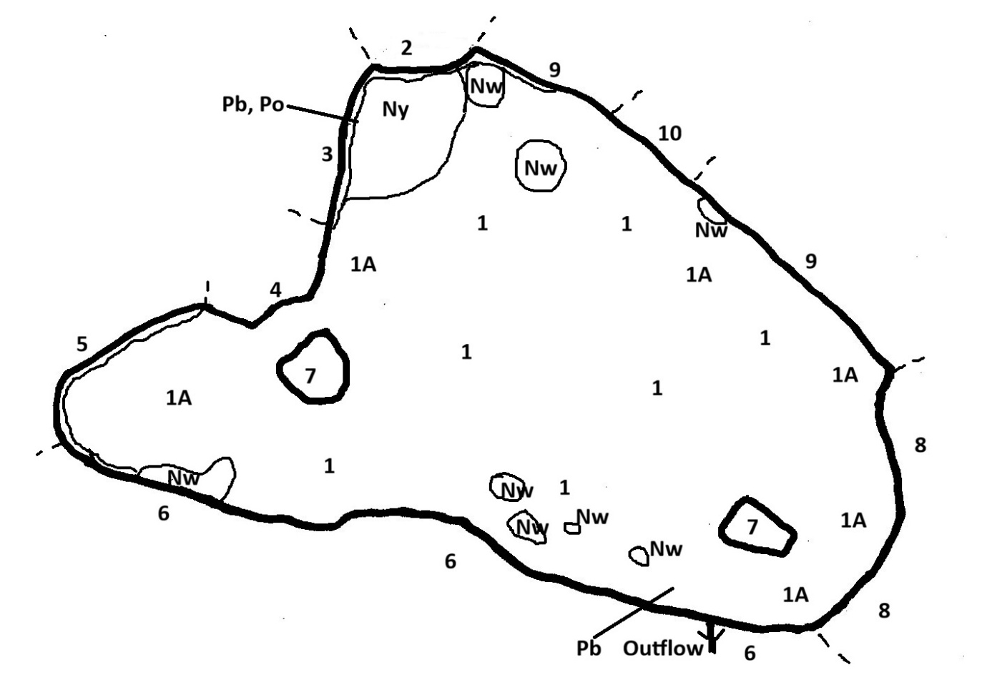
A medium-sized loch formed by embanking an area alongside the Fairgirth Lane. It is believed to have been created in the 1960s in connection with a chalet development on the slope above. The aim was to provide extra filtration for treated wastewater from the development before dispersing the water into the Fairgirth Lane. The embankment runs the full length of the southern side and east end.
It is a shallow loch dominated by Hornwort Ceratophyllum demersum and Nuttall’s Waterweed Elodea nuttallii with several substantial patches of water lilies. The edges are variously shaded with some areas where the trees overhang the loch edge but more commonly the trees are adjacent. There is an intermittent fringe of Yellow Flag Iris pseudacorus and Hemlock Water Dropwort Oenanthe crocata with these most developed where the shade is less.
1 – Open water with vegetation apparently all the way across, comprising Hornwort Ceratophyllum demersum and Nuttall’s Waterweed Elodea nuttallii with the former predominating. A boat was not used at this site, but the density appears to vary. In sheltered areas and near the edges (1A), the weeds often raft at the surface and there is frequent Duckweed Lemna (mainly Least Duckweed L. minuta) and some Cladophora algae but elsewhere the weed seems to be fairly free of algae.
Ny – Yellow Water Lily Nuphar lutea patch
Nw – Patches of Nymphaea cultivars of two types
Po – Blunt-leaved Pondweed Potamogeton obtusifolius a few plants.
Pb – Small Pondweed Potamogeton berchtoldii a few plants
2 – Edge unshaded. Yellow Flag Iris pseudacorus fringe to 5 metres wide.
3 – Trees adjacent and sometimes overshading. Yellow Flag Iris pseudacorus fringe to 5 metres wide.
4 – Willows overhanging the edges and no marginal fringe.
5 – Steep bank with trees adjacent but generally not overshading. Semi-continuous fringe of Yellow Flag Iris pseudacorus and Hemlock Water Dropwort Oenanthe crocata at margin.
6 – Embankment with 50 cm lip with wooden protection along loch edge. Intermittent Yellow Flag Iris pseudacorus and Hemlock Water Dropwort Oenanthe crocata along the margin, to one metre wide. Otherwise grassy bank with bramble patches.
7 – Wooded islands
8 – Embankment with willows and trees overhanging much of the edge. Some Yellow Flag Iris pseudacorus and Hemlock Water Dropwort Oenanthe crocata only where there are gaps in the shade.
9 – Edges unshaded although trees often adjacent. Fringe of Yellow Flag Iris pseudacorus and/or Hemlock Water Dropwort Oenanthe crocata.
10 – Willows overhanging edge. No marginal vegetation.
Comments: Wastewater from the chalet development enters the loch through a gusher in the SW bay. Although well-treated by this stage it is likely increasing the nutrient levels in the loch, reflected in the vigorous growth of aquatic vegetation throughout the loch. The main species is Hornwort Ceratophyllum demersum which is often an indicator of higher nutrients when it occurs in quantity and this is mixed with the non-native invasive Nuttall’s Waterweed Elodea nuttallii. The Nymphaea water lilies are cultivars and it is likely that the Yellow Water Lily was planted at the same time.
Nevertheless, a few plants of two native pondweeds were found in two places (Pb and Po on map).

Black Loch
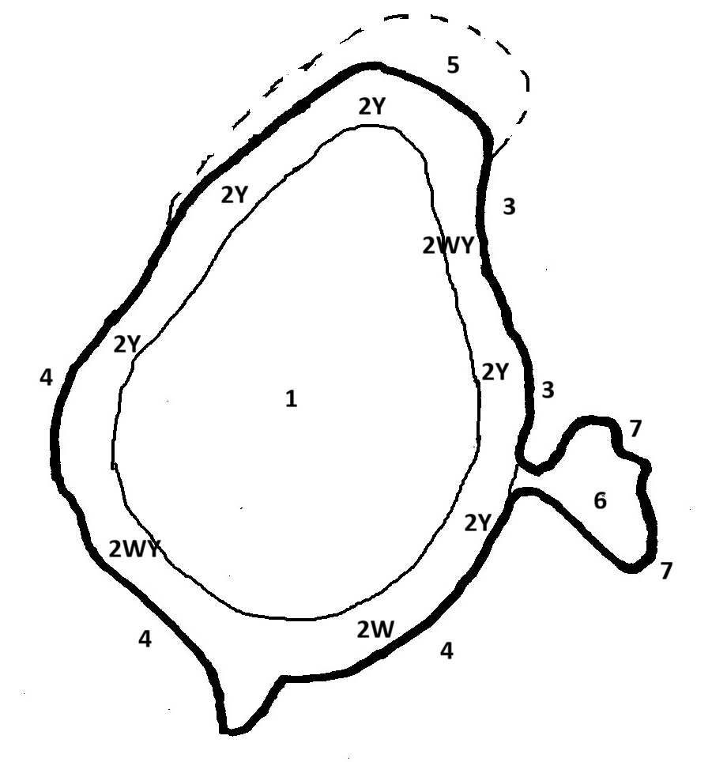
This is a small loch in what appear to be a kettle hole. It surrounded by peat, the margin of which is mostly floating fen and this is surrounded by wet woodland. The bottom drops away quite quickly to several metres depth and there is a ring of water lilies around the loch which has abundant submerged vegetation in the shallower parts. The water is coffee-coloured and there is a bit of fine diatom dust on the submerged vegetation in the shallows.
1 - Central part. Empty of vegetation and may be quite deep
2 – The water is surrounded by a broad band of water lilies, usually 10-15m wide, forming an open cover. There is a mix of White Water Lily (Nymphaea alba = 2W) and Yellow Water Lily (Nuphar lutea = 2Y) and some Broad-leaved Pondweed Potamogeton natans. In the marginal 2 metres the water is shallow and there is abundant Lesser Bladderwort Utricularia minor, Alternate Water Milfoil Myriophyllum alterniflorum and Translucent Stonewort Nitella translucens underneath. Beyond this the bottom drops away and there is some Translucent Stonewort Nitella translucens but soon this also disappears and there is nothing under the lilies.
3 - Band of floating fen all around the edge with varying amounts of Bottle Sedge Carex rostrata and Bog Moss Sphagnum, often with Marsh Cinquefoil Comarum palustre and Marsh St. John’s Wort Hypericum elodes in the water’s edge. Some young birch and backing onto taller birch over Bog Moss Sphagnum and Bottle Sedge Carex rostrata.
4 - More closely enclosed by wet woodland of birch and willow. Bog Moss Sphagnum carpet and Bottle Sedge Carex rostrata with Marsh Pennywort Hydrocotyle vulgaris, Marsh Cinquefoil Comarum palustre and Water Horsetail Equisetum fluviatile.
5 - Nice area of open fen with some young birch. Carex spp. (including some Bog Sedge Carex limosa and Lesser Tussock Sedge Carex diandra), Bog Asphodel Narthecium ossifragum, Many-stalked Spike-rush Eleocharis multicaulis.
6 - Sheltered bay with scattered Bog Pondweed Potamogeton polygonifolius, and some Lesser Bladderwort Utricularia minor and Alternate Water Milfoil Myriophyllum alterniflorum
7 – Sedge/rush margin. Sharp-flowered Rush Juncus acutiflorus, Bottle Sedge Carex rostrata, Marsh St. John’s Wort Hypericum elodes. Some runnels with Bog Pondweed Potamogeton polygonifolius.
Comments: An interesting site with a good aquatic flora and some very nice areas of species-rich fen, particularly at the north end. However, in the latter there are worries about encroaching birch/willow colonisation and these are likely to need cutting back at intervals. There is also a possibility to extend the fen by cutting back the woodland which is quite closely enclosing on the west side.

Clonyard Pond
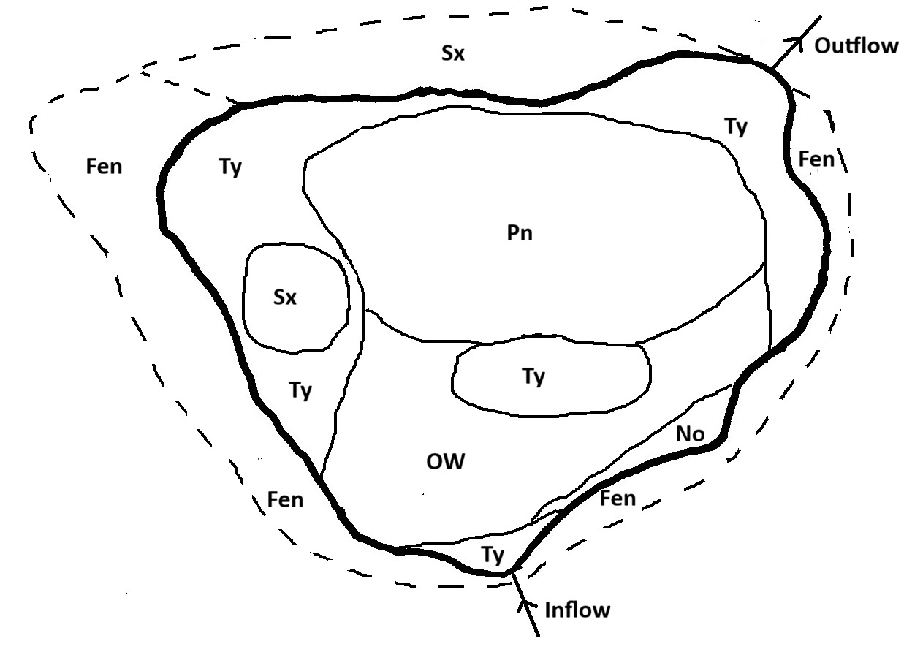
A small pond, which can be seen on OS maps in 1854 and originated as a water supply for a threshing mill at Clonyard Farm. It is all about 60 cm deep and is partially filled by swamp and with extensive Broad-leaved Pondweed Potamogeton natans
Sx – Willows
Ty – Bulrush Typha latifolia swamp
Pn – Water dominated by Broad-leaved Pondweed Potamogeton natans
OW – Open water, firm base but covered by 25cm of soft gooey mud (especially near the inflow).
No – Watercress Nasturtium officinale
Fen – Fen dominated by Bottle Sedge Carex rostrata at the wetter margin, with Water Mint Mentha aquatica, Marsh Pennywort Hydrocotyle vulgaris, Bulrush Typha latifolia, Marsh Cinquefoil Comarum palustre. Then dryer with abundant Meadowsweet Filipendula ulmaria etc.
Comment; Although a small site, there is a reasonable diversity of aquatics, including a good population of Dark Stonewort Nitella flexilis agg. and some Blunt-leaved Pondweed Potamogeton obtusifolius. Infilling with swamp but owners clear it out periodically.

Clonyard Loch
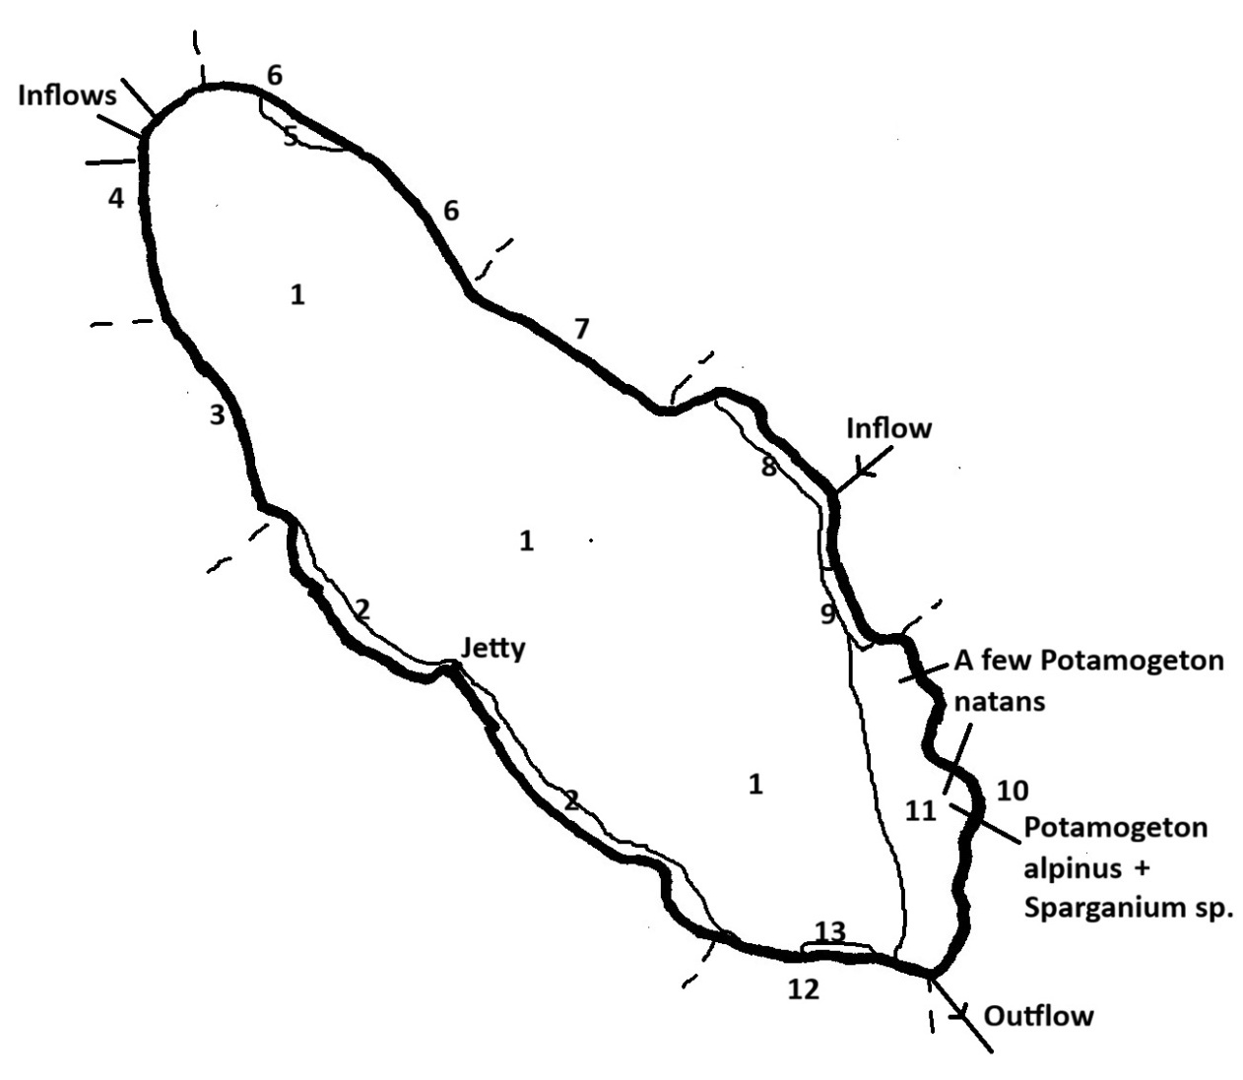
The smallest of the main lochs at Colvend, four hectares in extent and 8.5 metres at its deepest point. It is set within an area of woodland and improved pasture and there is a mixture of peaty and stony edges with some areas of wet woodland and fen. There are areas of swamps of various types around the margin where this is not overhung by trees, but, unlike many of the nearby lochs, water lilies are absent. The water is coffee-coloured and this limits the underwater vegetation which is largely restricted to the south-eastern end of the loch.
1 - Zero vegetation through most of lake even in unshaded shallows, due to strongly coffee-coloured water.
2 - Common Reed Phragmites australis and Common Club-rush Schoenoplectus lacustris swamp c.5 metres wide. Often backed by Bottle Sedge Carex rostrata, Marsh Cinquefoil Comarum palustre fen, then mixed Rush Juncus fen. Backed by woodland north of jetty.
3 - Stony shore shaded by overhanging willows. Local livestock access.
4 - Series of several inflow channels under willows feeding through willow carr with some Common Reed Phragmites australis. Very little flow in channels.
5 - Patch of Common Reed Phragmites australis and Bottle Sedge Carex rostrata
6 – Moderate slope down to loch. Grassy to edge or with rushes or sometimes stony. Fenced off but fence broken allowing grazing access.
7 – Margin ungrazed with overhanging willows. Shore stony and quite steep.
8 – Band of Common Reed Phragmites australis and Common Club-rush Schoenoplectus lacustris. Woodland on shore beyond
9 – Patch of Saw Sedge Cladium mariscus
10 – Thin band of willows with pasture beyond. Willows overhanging but not continuous. Grazing access. Shore generally stony where shaded but some areas more grassy with rushes, particularly where there are breaks in the shade.
11 – Shallow area to 1.5 metres deep. Quite stony in the shallows with no vegetation but softer offshore with frequent Willow Moss Fontinalis antipyretica. Some Blunt-leaved Pondweed Potamogeton obtusifolius and Dark Stonewort Nitella flexilis agg. scattered through and a few patches of Broad-leaved Pondweed Potamogeton natans, Red Pondweed Potamogeton alpinus and Unbranched? Bur-reed Sparganium ?emersum (not flowering)
12 - Overhanging willow band with pasture beyond although there is a narrow band of fen between
13 - Patch of Common Reed Phragmites australis and Bulrush Typha latifolia
Comment: Although much of the loch is unvegetated, there is an interesting area at the south-eastern end including Red Pondweed Potamogeton alpinus, Blunt-leaved Pondweed Potamogeton obtusifolius and Unbranched? Bur-reed Sparganium ?emersum. It is unclear why this area has more vegetation, whether depth and substrate favour it or due to some richer influences from the inflow from Barean Loch. The good stand of Saw Sedge Cladium mariscus is also of note.

Drumstinchall Loch
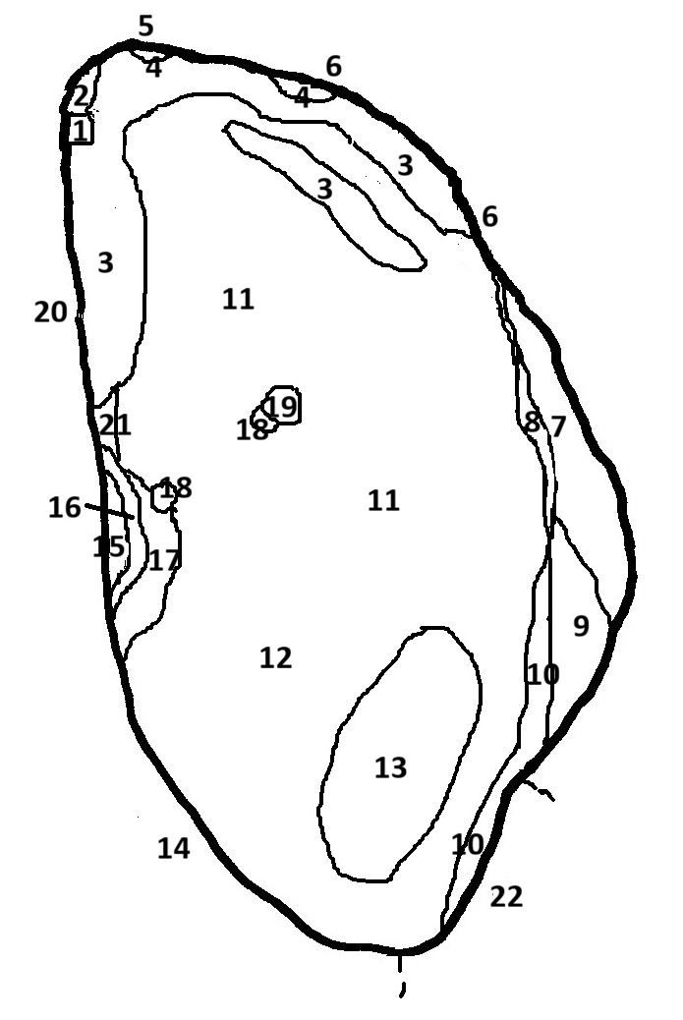
This is a small loch formed by a dam along the south-western side and it first appears on maps around 1950. It seems to be uniformly shallow, up to 1 metre depth, and is vegetated all of the way across. The water is coffee-coloured. The main vegetation is Willow Moss Fontinalis antipyretica with frequent Ivy-leaved Duckweed Lemna trisulca with extensive patches of Amphibious Bistort Persicaria amphibia towards the south end. There are extensive areas of Water Horsetail Equisetum fluviatile swamp of varying density around the edges and in places extending some distance out into the middle. There are also smaller patches of a variety of swamp species around the margins (Branched Bur-reed Sparganium erectum, Bottle Sedge Carex rostrata, Bulrush Typha latifolia, Common Spike-rush Eleocharis palustris, Bogbean Menyanthes trifoliata, Floating Sweet Grass Glyceria fluitans, Water Plantain Alisma plantago-aquatica and one clump of the normally maritime Sea Club Rush Bolboschoenus maritimus). On the east side there is a substantial area of Reed Canary Grass Phalaris arundinacea which seems to be accreting into the loch, including an area on the south-east side where there are runnels percolating through the Phalaris and these contain several soft water species not seen elsewhere in the loch (Bog Pondweed Potamogeton polygonifolius, Water Purslane Lythrum portula, Intermediate Water Starwort Callitriche brutia).
1 - Boathouse and jetty
2 – Patch of Bogbean Menyanthes trifoliata in shelter of jetty
3 – Water Horsetail Equisetum fluviatile often forming quite an open cover but in some areas quite dense
4 – Patches of Branched Bur-reed Sparganium erectum
5 – Dry bank with mainly Reed Canary Grass Phalaris arundinacea
6 – Dry bank with coarse grass with 3 metre strip of damp Reed Canary Grass Phalaris arundinacea at margin. Some Water Plantain Alisma plantago-aquatica, Water Mint Mentha aquatica, Marsh Bedstraw Galium palustre.
7 – 20 metre wide band of damp Reed Canary Grass Phalaris arundinacea with frequent Meadowsweet Filipendula ulmaria and patches of Yellow Flag Iris pseudacorus. Also some Nettle Urtica dioica, terrestrial Amphibious Bistort Persicaria amphibia, Greater Bird’s-foot-trefoil Lotus pedunculatus, Soft Rush Juncus effusus. Willows on slope behind.
8 – Margin with semi-continuous but individual species patches of Bottle Sedge Carex rostrata, Water Horsetail Equisetum fluviatile and Branched Bur-reed Sparganium erectum, 3-5 metres wide.
9 - Interesting wetland area where streamlets merge through swamp into lake. Mainly Reed Canary Grass Phalaris on the landward side merging with Water Horsetail Equisetum fluviatile towards the loch. Some Bog Pondweed Potamogeton polygonifolius, Common Duckweed Lemna minor, Intermediate Water Starwort Callitriche brutia, Water Purslane Lythrum portula.
10 – Water Horsetail Equisetum fluviatile swamp of varying density.
11 – Main body of loch dominated by Willow Moss Fontinalis antipyretica with frequent Lemna trisulca
12 – As 11 but scattered patches of Amphibious Bistort Persicaria amphibia
13 – Extensive beds of Amphibious Bistort Persicaria amphibia
14 – Dam wall, vertical on loch side, rising 50 cm above water. Some Japanese Knotweed Reynoutria japonica on the dam
15 – Dry bank below embankment with frequent Meadowsweet Filipendula ulmaria
16 – Band of Bottle Sedge Carex rostrata
17 – Mixture of Amphibious Bistort Persicaria amphibia, Water Plantain Alisma plantago-aquatica and Common Spike-rush Eleocharis palustris.
18 – Patches of Bulrush Typha latifolia
19 – Island, dominated by Reed Canary Grass Phalaris arundinacea
20 – Dry grassy bank with footpath on top.
21 - Floating Sweet-grass Glyceria fluitans and Common Spike-rush Eleocharis palustris
22. – Steep slope with willows and trees overhanging edge.
Comments: The main aquatic species in the loch are nutrient-tolerant species suggesting that there may be some enrichment. Indeed, abundant growths of Willow Moss Fontinalis antipyretica can often indicate enrichment. However, there is no significant growth of filamentous algae and only small amounts of Duckweed Lemna, which are both other typical indicators.
Because of the shallowness of the loch, swamp communities are well developed. The site supports an interesting array of swamp species. This includes a clump of Sea Club-rush Bolboschoenus maritimus, a species normally associated with brackish marshes. Its occurrence here is anomalous and could indicate that there may have been introductions when the loch was created to enhance the vegetation.
Swamp communities appear to be expanding on the eastern side and there is an interesting area on the SE side (9) where a stream inflow percolates through the swamp. This supports several soft water aquatics not seen elsewhere in the loch, suggesting a cleaner water source.

Duff’s Loch
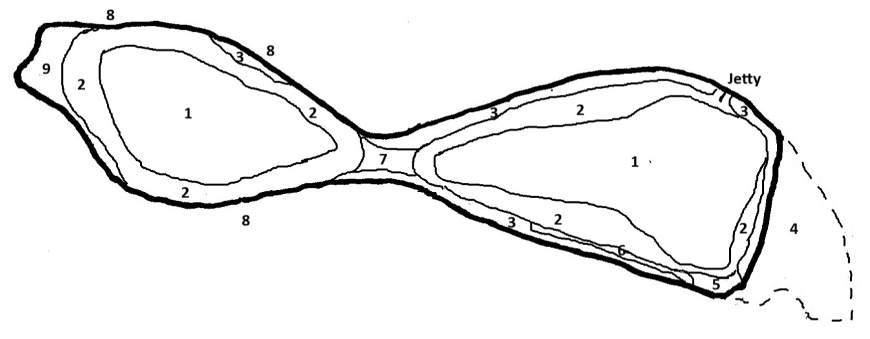
A small loch comprising two basins separated by a bank of reeds. The water is coffee-coloured and up to 4 metres deep. Both parts are similar in being fringed by reeds and a band of Yellow Water Lily Nuphar lutea but unvegetated in the deeper parts across the middle. The twin basins are surrounded by willows often overhanging the back of the reeds with damp woodland beyond.
1 – Deep water, unvegetated
2 – Broad band of Yellow Water Lily Nuphar lutea, mostly 15-20 metres wide. Extends to c.2.5 metres depth. No vegetation beneath.
3 - Common Reed Phragmites australis band 10+ metres wide and extending to 1.5m depth. Becomes thinner on the loch-ward side with Yellow Water Lily Nuphar lutea penetrating amongst the reeds. Landward side of reeds overhung by willows. The reeds are generally tall, often 3 metres above the water.
4 – Some thinner areas in the reeds allow access to the true lake edge. Margin is shallow lip to floating peat surface with Bottle Sedge Carex rostrata and Marsh Cinquefoil Comarum palustre under Common Reed Phragmites australis. This extends 40 metres back from loch edge here. In the water the bottom drops straight down to 1 metre depth.
5 - Gap in reed fringe, unvegetated. Still Yellow Water Lily Nuphar lutea ring offshore
6 – Outer half of reed fringe is only thin cover of Reed Phragmites with Yellow Water Lily Nuphar lutea growing underneath.
7 – Channel between basins now Reed dominated but density variable and Yellow Water Lily Nuphar lutea frequent where the Reed cover is less dense
8 – Apart from the areas marked as swamp, there is only a thin margin of Reed between the overhanging willows and the Yellow Water Lily ring and in some places the willows overhang right to the back of the Yellow Water Lily ring. Under the willows there is wet woodland with Bottle Sedge Carex rostrata, Common Reed Phragmites australis, Marsh Cinquefoil Comarum palustre, Water Mint Mentha aquatica etc.
9 – Common Reed Phragmites australis with some Common Club-rush Schoenoplectus lacustris and Water Horsetail Equisetum fluviatile.
Comments: Surprisingly limited variety of aquatic species due to the high water colour and the steep drop around the edges. Secchi depth was 1.2 metres while much of the loch is deeper than this so that little light reaches the bottom. Nevertheless, some Blunt-leaved Pondweed Potamogeton obtusifolius was found near the jetty and there is a good range of swamp species. There is minimal disturbance affecting the site and no significant indications of enrichment.

Dunmuck Lower Pond

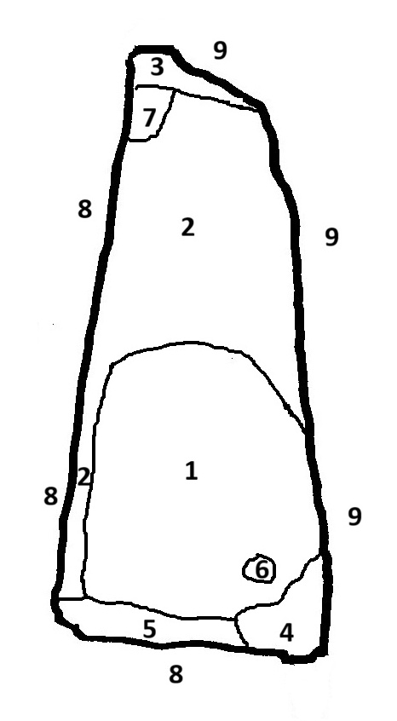
A small lake surrounded by trees set within a landscape of woodlands and improved pasture. It was formed by embanking an area adjacent to, but at a higher level than, the Parruten Burn. It appears to be present on aerial photographs in 1988 but the image is not clear. It is partially filled by Water Horsetail Equisetum fluviatile swamp and is dominated by Broad-leaved Pondweed Potamogeton natans and the edges are largely shaded by overhanging trees. The water is tea-coloured and is maybe 1.5 metres deep but the bottom is soft and so is difficult to wade.
1 – Broad-leaved Pondweed Potamogeton natans dominated with some scattered Water Horsetail Equisetum fluviatile.
2 – Water Horsetail Equisetum fluviatile and Broad-leaved Pondweed Potamogeton natans, the latter sometimes replaced by Bog Pondweed Potamogeton polygonifolius in the shallows.
3 – Bottle Sedge Carex rostrata swamp
4 – Bulrush Typha latifolia swamp
5 – Water Horsetail Equisetum fluviatile swamp
6 – Patch of Water Lily Nymphaea cultivar
7 – Patch of Cape Pondweed Aponogeton distachyos among Water Horsetail Equisetum fluviatile
8 – Embankments with willows, alder and birch overhanging the edge.
9 – Natural bank with willows overhanging the edge.
Comment: The Cape Pondweed Aponogeton distachyos and Water Lily Nymphaea cultivar are both introductions. However, there is no evidence that they are spreading or causing any problems. The vegetation of the site looks pretty stable but the Water Horsetail Equisetum fluviatile swamp is likely to increase over time. Images from Google Earth (below) indicate that the trees around the loch have grown up considerably over the last 20 years.
2009 2018
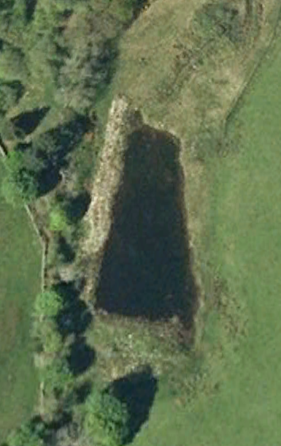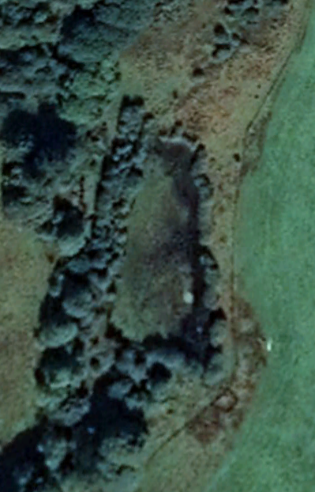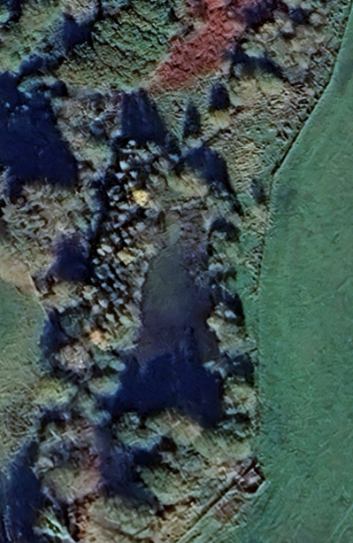
2025
Dunmuck Upper Pond

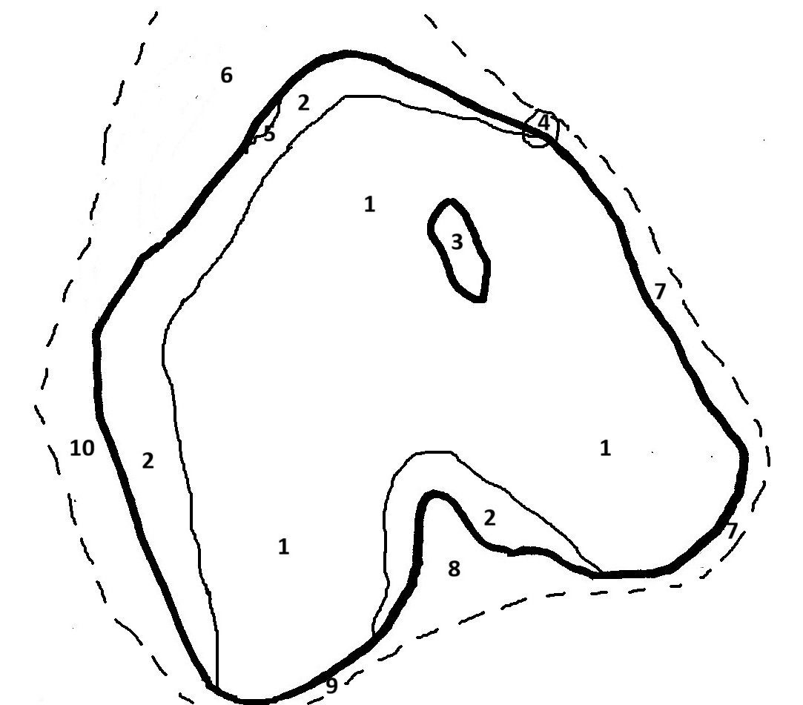
This pond is present on aerial photographs in 1988. It is a large pond up to around 1.5 metres deep with water colour of weak tea. It is fenced off from grazing and is surrounded by rush pasture with hardly any trees. It is very largely dominated by Broad-leaved Pondweed Potamogeton natans but there is a band around this in up to 50 cm depth with a mixed aquatic community including Floating Club-rush Eleogiton fluitans, Needle Spike-rush Eleocharis acicularis and Lesser Marshwort Helosciadium inundatum. There is also frequently a fringe of Common Spike-rush Eleocharis palustris at the water’s edge.
1 – Main body of pond dominated by Broad-leaved Pondweed Potamogeton natans with a few patches of Bur-reed Sparganium sp.
2 - Open band in up to 50 cm depth with Floating Club-rush Eleogiton fluitans, Needle Spike-rush Eleocharis acicularis and Lesser Marshwort Helosciadium inundatum. Common Spike-rush Eleocharis palustris fringe at margin.
3 – Island, mainly rushy.
4 – Willow bush
5 – Patch of Branched Bur-reed Sparganium erectum at edge.
6 – Rush pasture with patches of Branched Bur-reed Sparganium erectum.
7 – Thin band of rush pasture then woodland. Mostly rushes at water’s edge. The bottom shelves quite steeply on this side but there is still a narrow open strip in the water as 2.
8 – Rush pasture with Creeping Bent Agrostis stolonifera and Soft Rush Juncus effusus.
9 – Narrow rush pasture. Partial fringe of Common Spike-rush Eleocharis palustris
10 – Rush pasture.
Comments: The open band in the shallows around the Broad-leaved Pondweed Potamogeton natans contains good populations of three uncommon species: Floating Club-rush Eleogiton fluitans, Needle Spike-rush Eleocharis acicularis and Lesser Marshwort Helosciadium inundatum. Needle Spike-rush Eleocharis acicularis, for example, has only previously been recorded in eastern Kirkcudbrightshire from Southwick Loch where the habitat is no longer suitable. The maintenance of this open band is important for the diversity of this site. It may be that the water level fluctuates seasonally as the Broad-leaved Pondweed Potamogeton natans requires to be more or less permanently in water. It is not known if livestock are allowed to graze the pond edge occasionally; low levels of grazing might also help keep the vegetation in the shallows more open and might also increase diversity in the surrounding rush pasture.

Fairgirth Loch
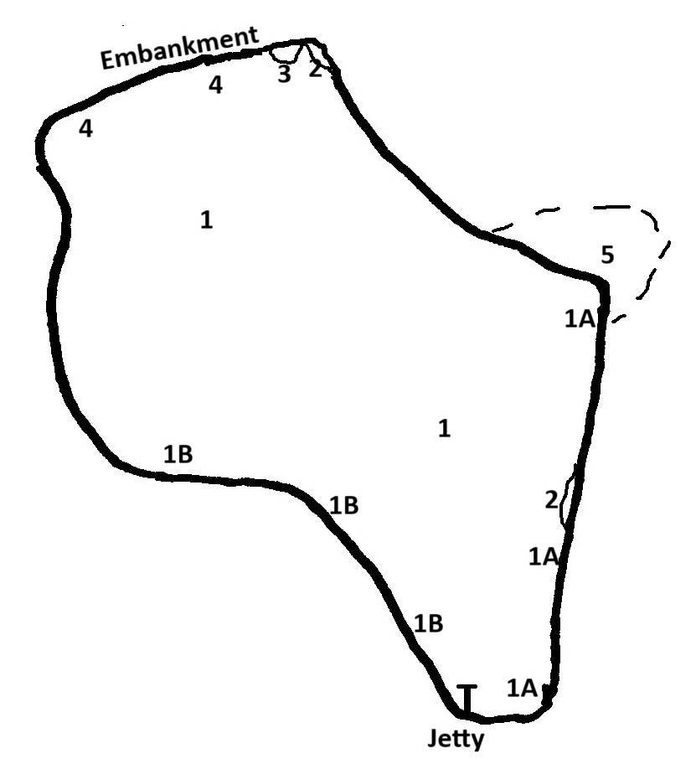
A small lake formed by damming with an embankment across a shallow valley of the Fairgirth Lane, sometime in the 1990s or 2000s. Probably about 1 metre deep at the south end to 2 metres near the dam at the north end. The water is cloudy and slightly greenish. It is mostly surrounded by moderate to steep banks rising a metre above the water but there is a more gradual slope by the farm at the south end. The banks have short grass and are open to grazing all round. There are frequent rushes at the water’s edge but locally there is a wider band to 2 metres of rush pasture at the edge.
1 - Water dominated by Nuttall’s Waterweed Elodea nuttallii throughout, including right into the shallows where there are occasional scatters of Floating Sweet Grass Glyceria fluitans and Bur-reed Sparganium sp. (?young leaves of Sparganium erectum). Often there is a light covering of Cladophora-algae over the top of the Elodea.
1A - SE side - still Elodea dominant but scum of floating Cladophora-algae mats in edge with Common Duckweed Lemna minor caught amongst it. Also, accumulations of blue-green planktonic algae at the edge and sparsely offshore.
1B – SW side - Occasional Alternate Water-milfoil Myriophyllum alterniflorum and Small Pondweed Potamogeton berchtoldii among the Elodea. Still Common Duckweed Lemna minor and Cladophora scum at the margin
2 – Small patches of Bulrush Typha latifolia
3 – Treeless around the edge except one lone willow in the NE corner.
4 – N side formed by embankment, edge bouldery and unvegetated
5 – Area of nice flushes on slope feeding into the loch
Comments: The dominance of the non-native Nuttall’s Waterweed Elodea nuttallii reduces the interest of this loch. There are a few areas where native aquatic species survive among the Elodea but these may well become overwhelmed in time. The presence of Cladophora-algae and some accumulation of blue-green planktonic algae suggest that there is some enrichment occurring.

Golf Course Ponds
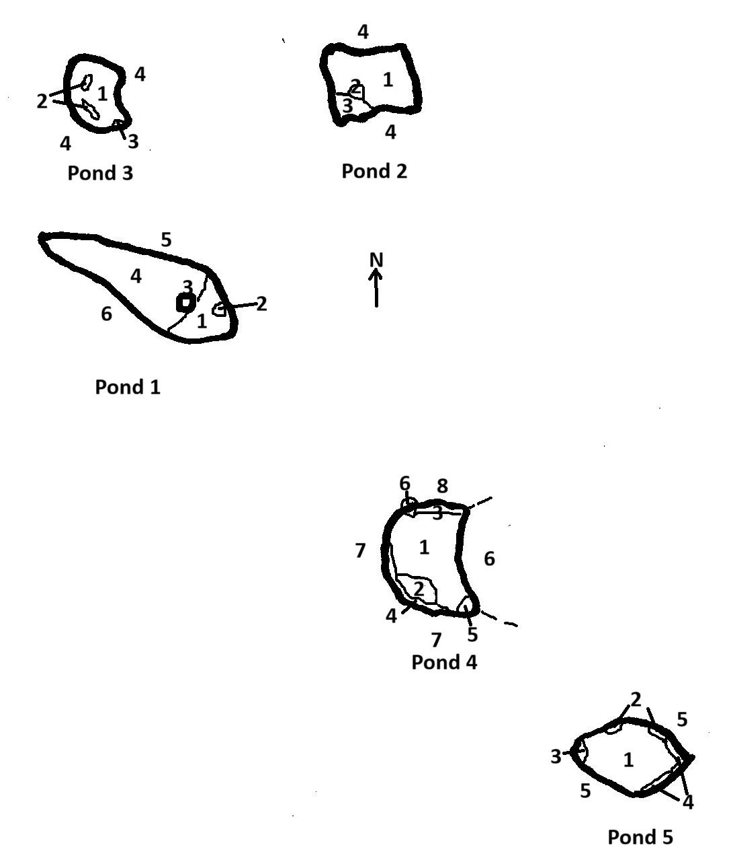
Golf Course Pond 1
Semi-circular pond to 60 cm deep with coffee-coloured water. Wooded on south side, open and grassy to the north. Patchy but locally dense Broad-leaved Pondweed Potamogeton natans and Water Lily Nymphaea cultivar.
1 - Dense Broad-leaved Pondweed Potamogeton natans
2 – Patch of Water Lily Nymphaea cultivar
3 – Island with willow
4 – Open patchy Water Lily Nymphaea cultivar and Broad-leaved Pondweed Potamogeton natans. No submerged vegetation
5 – Open shore with low 30 cm lip up to Creeping Bent Agrostis stolonifera and Sharp-flowered Rush Juncus acutiflorus. A few young willows and alder to 2 metres tall.
6 – Overhanging willows. Moderately steep bank beneath with grass and ferns.

Golf Course Pond 2
Pond surrounded by grassy banks. Patchy cover of Bog Moss Sphagnum and locally some Broad-leaved Pondweed Potamogeton natans and Bog Pondweed Potamogeton polygonifolius. Water coffee-coloured and to 50 cm deep.
1 – Submerged Bog Moss Sphagnum abundant but patchy.
2 – Patches of Broad-leaved Pondweed Potamogeton natans
3 – Scattered Bog Pondweed Potamogeton polygonifolius
4 – Pond surrounded by 30 cm lip or low bank with Creeping Bent Agrostis stolonifera, some Marsh Pennywort Hydrocotyle vulgaris and tufts of Sharp-flowered Rush Juncus acutiflorus.

Golf Course Pond 3
The smallest of the ponds. The water is coffee-coloured and up to 40 cm deep. The water is dominated by Small Pondweed Potamogeton berchtoldii with patches of Broad-leaved Pondweed Potamogeton natans, Common Spike-rush Eleocharis palustris and Bur-reed Sparganium sp. Surrounded by grassy banks.
1 – Water dominated by Small Pondweed Potamogeton berchtoldii with occasional groups of Common Spike-rush Eleocharis palustris and Bur-reed Sparganium sp (floating-leaved). There is a covering of Cladophora-algae over the underwater vegetation. There is some Bulbous Rush Juncus bulbosus in the shallows.
2 – Patches of Broad-leaved Pondweed Potamogeton natans
3 – Small patch of Bottle Sedge Carex rostrata
4 – Surrounded by 30-50 cm grassy bank with occasional Sharp-flowered Rush Juncus acutiflorus.

Golf Course Pond 4
This pond is about 60 cm deep with coffee-coloured water. It is quite well vegetated with floating and submerged species, including four different Pondweed Potamogeton species. At the edge there is locally frequent Water Horsetail Equisetum fluviatile and one patch of Reed Sweet Grass Glyceria maxima.
1 - Mixture of Broad-leaved Pondweed Potamogeton natans, Small Pondweed Potamogeton berchtoldii and Blunt-leaved Pondweed Potamogeton obtusifolius with patchy Water Horsetail Equisetum fluviatile. There is a general cover of scummy algae over the submerged vegetation.
2 – Broad-leaved Pondweed Potamogeton natans patch
3 – Open shallows with some Bog Pondweed Potamogeton polygonifolius and Bulbous Rush Juncus bulbosus.
4 – Fringe of Water Horsetail Equisetum fluviatile.
5 – Patch of Reed Sweet Grass Glyceria maxima
6 – Willows
7 – Steep banks with a narrow band of rushes at the base.
8 – Low lip at edge to grass and rushes

Golf Course Pond 5
This pond had been cleaned out within the previous year but swamp species, particularly Bulrush Typha latifolia are already beginning to regenerate. It is about 60 cm deep and the bottom is soft mud. The aquatic vegetation is also rather patchy with particularly Broad-leaved Pondweed Potamogeton natans and Blunt-leaved Pondweed Potamogeton obtusifolius.
1 – Main body of pond with scattered young Bulrush Typha latifolia and sparse patches of Blunt-leaved Pondweed Potamogeton obtusifolius and Broad-leaved Pondweed Potamogeton natans. There is also some Floating Sweet Grass Glyceria fluitans and Bur-reed Sparganium sp. Common Water Starwort Callitriche stagnalis and Bulbous Rush Juncus bulbosus are also present but rare.
2 – Alder trees.
3 – Bulrush Typha latifolia patch
4 – Intermittent Bulrush Typha latifolia along east shore
5 – Steepish bank all round. Mostly rough grass but some rushes at water’s edge
Comment: This site comprises five ponds created as hazards for the golf course and perhaps also as an extra water supply in dry weather. They are each rather different in character with some rather sparsely vegetated and some more strongly so. There is a range of aquatic species, including four species of Pondweed Potamogeton, and also several swamp species. Pond 5 had been fairly recently cleaned out and the main swamp species here Bulrush Typha latifolia is able to colonise quite quickly, so this pond may need clearing on a regular basis. The other ponds may also need a clear out from time to time.

Jennifer’s Pond
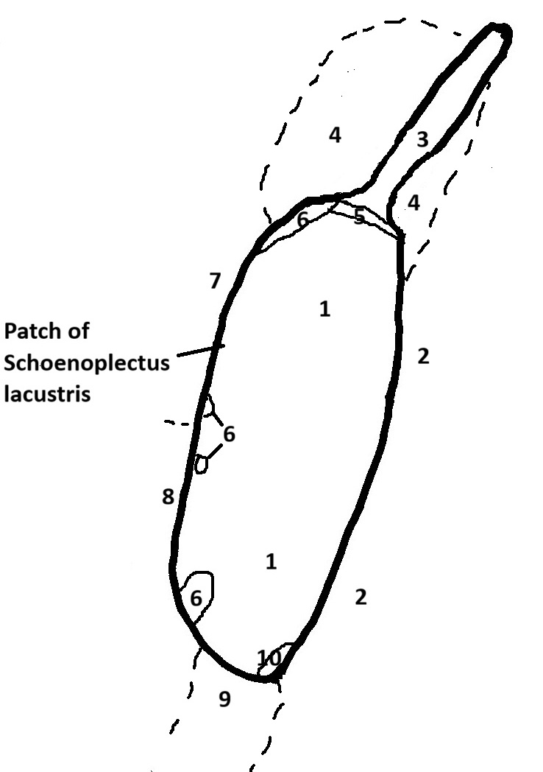
This is a large pond surrounded by cattle-grazed improved pasture with areas of rush pasture. The water is coffee-coloured and a bit cloudy. It seems to be about one metre deep but the bottom is very soft making it unsafe to wade out into the pond. A lot of the edge is quite poached and in places this is causing the edge to erode back leaving islands of Rush Juncus and Bur-reed Sparganium offshore. The bottom is soft mud and there is only a small amount of aquatic vegetation (Broad-leaved Pondweed Potamogeton natans, Duckweed Lemna minor and Water Starwort Callitriche stagnalis).
1 – Soft mud bottom. No vegetation.
2 – Edge poached but not eroding. Semi-continuous 0.5 metre margin of Floating Sweet Grass Glyceria fluitans
3 – Branched Bur-reed Sparganium erectum infilled channel
4 – Rush pasture
5 – Common Spike-rush Eleocharis palustris frequent along margin
6 – Branched Bur-reed Sparganium erectum patch
7 – Grassy bank with boulders, poached but not eroding
8 – Strongly poached and edge eroding back leaving islands of Rush Juncus and Bur-reed Sparganium
9 – Rush pasture poached and soft near pond edge.
10 – Unbranched Bur-reed Sparganium emersum patch
Comments: The main interest of this pond is the range of emergent species in such a small area. This includes small amounts of Unbranched Bur-reed Sparganium emersum and Common Club-rush Schoenoplectus lacustris which are local species in the area. However, this pond suffers from significant grazing pressure causing erosion along part of the shore and distributing silt into the bottom of the pond. As a result, the aquatic vegetation is limited.

Newbarns Loch
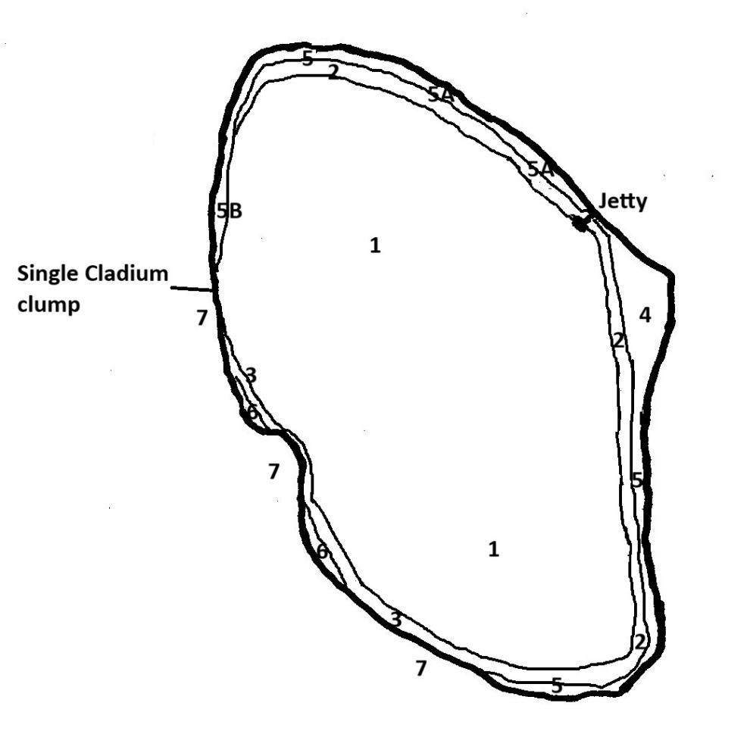
This is a small loch in what was probably a kettle hole. It is fringed by wet woodland on peat with a band of swamp around much of the margin (mostly Common Reed Phragmites australis and Bottle Sedge Carex rostrata with some areas of Saw Sedge Cladium mariscus and Bogbean Menyanthes trifoliata. The bottom then drops away quite quickly to several metres depth and there is a ring of White Water Lily Nymphaea alba around much of the loch. The water is coffee-coloured.
1 - Central body of loch unvegetated. Vegetation restricted to a few metres around the margins.
2 – Open cover of White Water Lily Nymphaea alba about 5 metres wide
3 – White Water Lily Nymphaea alba only sparse along west side and absent from part of NW edge.
4 – Bays with thin cover of Common Reed Phragmites australis. Nice area of fen vegetation at margin of loch south of jetty with Many-stalked Spike-rush Eleocharis multicaulis, Marsh St-John’s-wort Hypericum elodes, Marsh Lousewort Pedicularis palustris, Marsh Cinquefoil Comarum palustre.
5 – Band of Common Reed Phragmites australis and Bottle Sedge Carex rostrata c.5 metres wide round east and north sides. Backed by wet woodland with Bog Moss Sphagnum, Common Reed Phragmites australis and Bottle Sedge Carex rostrata along outer edge, becoming dryer inland.
5A – As 5 but mixed with Saw Sedge Cladium mariscus
5B – As 5 with Bogbean Menyanthes trifoliata on loch-ward edge.
6 – Bottle Sedge Carex rostrata patches
7 – Willows more or less overhanging edge. Wet woodland with only a few patches of Bottle Sedge Carex rostrata at margin but some Common reed Phragmites and Bottle Sedge Carex rostrata under the willows.
Comment: Surprisingly low diversity of aquatic species, probably because of the steeply shelving edges and the strongly coloured water. However, there are some good patches of Saw Sedge Cladium mariscus among the swamp and a nice area of fen vegetation south of the jetty.

Pond opposite Clonyard
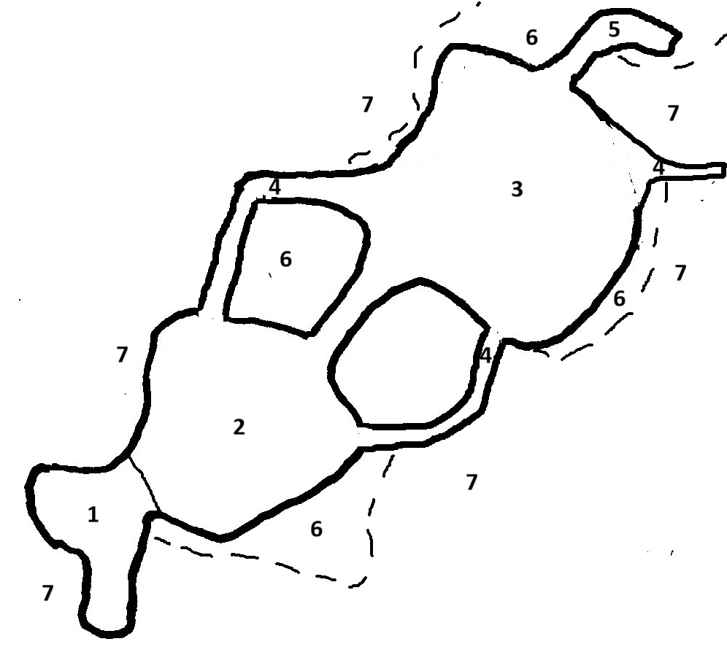
A shallow pond with a complex outline including shallow channels cutting through the surrounding fen/carr. Possibly was an older pond which has been enlarged. Water espresso-coloured and bottom soft mud with little vegetation. Mostly too soft to wade. The pond complex is within an area fenced off from grazing.
1 – Shallow channel under willows. Little vegetation.
2 – Unshaded. Some Broad-leaved Pondweed Potamogeton natans patches but otherwise unvegetated
3 – The largest open area with some patches of Broad-leaved Pondweed Potamogeton natans. There are a few islets in the middle with Rush Juncus and/or young willows.
4 – Channels with shallow water. Locally some Bog Pondweed Potamogeton polygonifolius where deeper
5 – Deeper inlet, unvegetated.
6 - Unshaded thick rushes
7 – Willows over grass and rushes
Comment: High peatiness and soft substrate limits the aquatic vegetation here. But there are still a few aquatic species including Blunt-leaved Pondweed Potamogeton obtusifolius.

Southwick House Pond
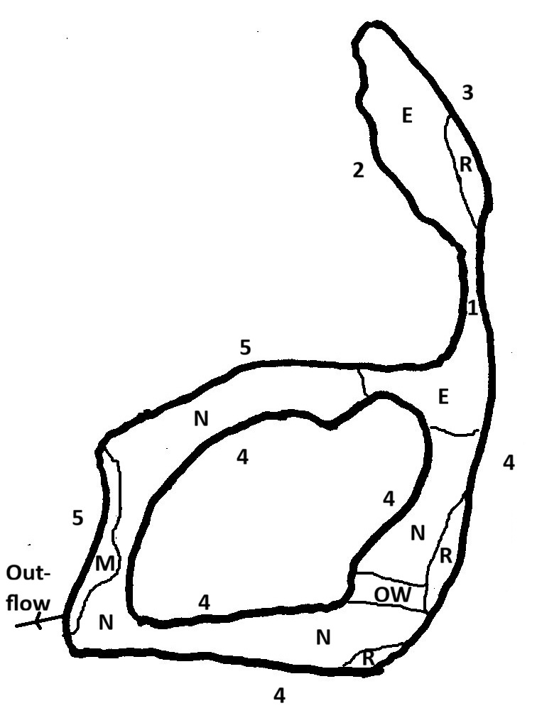
An ornamental pond set within formal gardens and visible on maps since 1967. It is essentially a linear channel with the lower half of it forming a loop around an island. It is surrounded by steepish 1-2 metre banks with ornamental shrubs shading out over the water in some places. Where unshaded there are intermittent patches of Reed Canary Grass Phalaris arundinacea, Yellow Flag Iris pseudacorus etc. along the water’s edge and more extensive patches of Greater Spearwort Ranunculus lingua and Bogbean Menyanthes trifoliata. The water is dominated by either Nuttall’s Waterweed Elodea nuttallii or Fringed Water Lily Nymphoides peltata
E – Nuttall’s Waterweed Elodea nuttallii dominant
N – Fringed Water Lily Nymphoides peltata dominant
R – Greater Spearwort Ranunculus lingua swamp
M – Bogbean Menyanthes trifoliata swamp
OW – Small area of unvegetated open water
1 – Water runs through unvegetated channel with 1 metre drop. Largely shaded
2 – Intermittent Greater Spearwort Ranunculus lingua, Yellow Flag Iris pseudacorus, Reed Canary Grass Phalaris arundinacea along margin with ornamental shrubs and trees on bank
3 – Lawn with ornamental trees to edge
4 – Patchily shaded. Not many emergent plants at edge apart from Greater Spearwort Ranunculus lingua and Bogbean Menyanthes trifoliata patches as marked.
5 – Mixture of shaded parts and more open areas with patches of Reed Canary Grass Phalaris arundinacea, Yellow Flag Iris pseudacorus, Greater Spearwort Ranunculus lingua. Some more gradually sloping banks with lawn descending to edge.
Comment: This is an artificial ornamental pond heavily dominated by non-native species. Although Greater Spearwort Ranunculus lingua and Bogbean Menyanthes trifoliata are both native species, it is likely that these are also planted for ornament here. The Nuttall’s Waterweed Elodea nuttallii and Fringed Water Lily Nymphoides peltata are aggressive species but there is little risk of them spreading to other water bodies in the area.

Also
In the middle of the walled garden there is a brick-lined lily pond about 10 metres by 2 metres. This is filled with two cultivars of ornamental Water Lily Nymphaea and scattered Bogbean Menyanthes trifoliata.

Southwick Loch
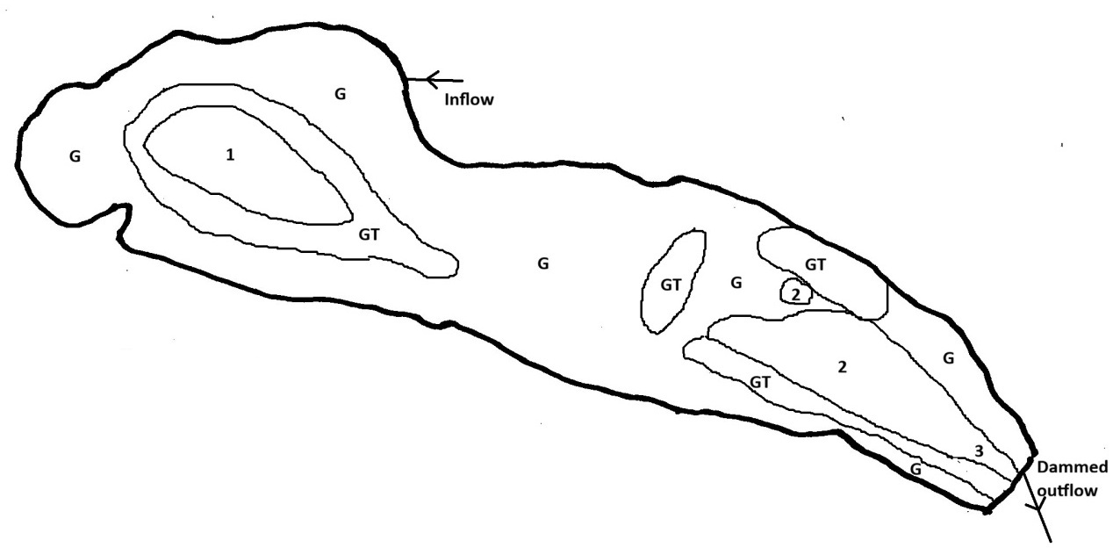
This was previously a fishing lake created in the 1950s, formed by damming the Brough Burn. It is now very largely swamp with two open areas remaining, dominated by Broad-leaved Pondweed Potamogeton natans.
1 – Open water dominated by Broad-leaved Pondweed Potamogeton natans with widespread covering of Spirogyra-type algae and scattered Common Duckweed Lemna minor on the surface. Some Dark Stonewort Nitella flexilis agg. was seen in the NW part of this area. Water mainly 1 metre to 1.5 metre deep.
2 – Open water dominated by dense Broad-leaved Pondweed Potamogeton natans.
3 – Channel to dam more open. Some Bur-reed Sparganium sp in channel by dam (in flowing water and probably submerged/floating leaves of Branched Bur-reed Sparganium erectum).
The swamp areas are generally quite dense and with water to 80+ centimetres near the open areas but shallowing to dry near the edges. Together with soft mud makes this makes wading access difficult.
G – Dense Reed Sweet Grass Glyceria maxima
GT – Glyceria maxima mixed with Bulrush Typha latifolia. These areas generally have deeper water and probably represent the most recently swamp-colonised sections.
Comment: This site is rapidly progressing towards swamp and images from Google Earth indicate that much of this has happened within the last 20 years. Nevertheless, the depth will probably mean that some pools remain open for a while yet. Neither the swamp nor the open water are particularly species-rich although the occurrence of Dark Stonewort Nitella flexilis agg. is notable. Records from the 1980s and 1990s indicate that the loch had a more diverse aquatic flora. Although it would be beneficial to clear the loch again, this would be a huge undertaking with large quantities of mud and plant material to dispose of. The presence of some algae suggests that there may be some enrichment run-off from the surrounding improved pasture, and this may be encouraging the swamp colonisation.

Images from Google Earth:
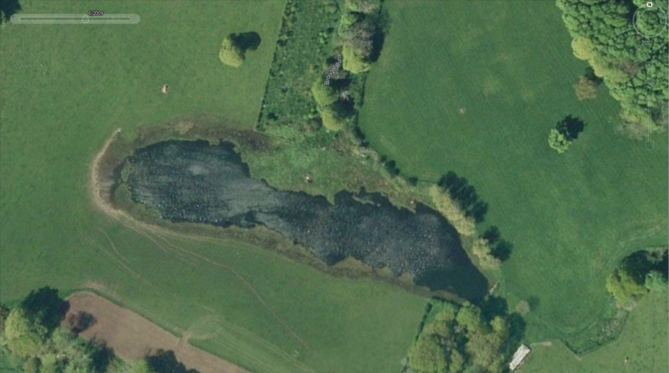
2009
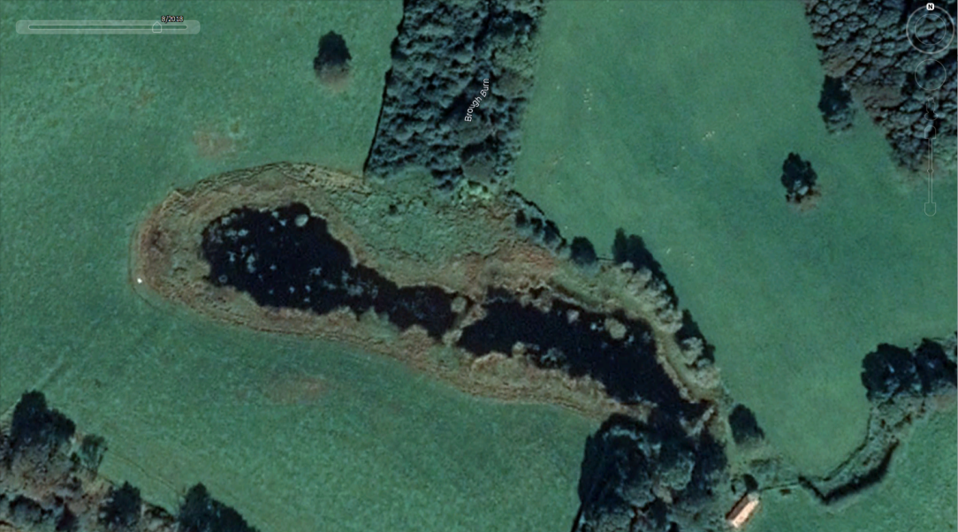
2018
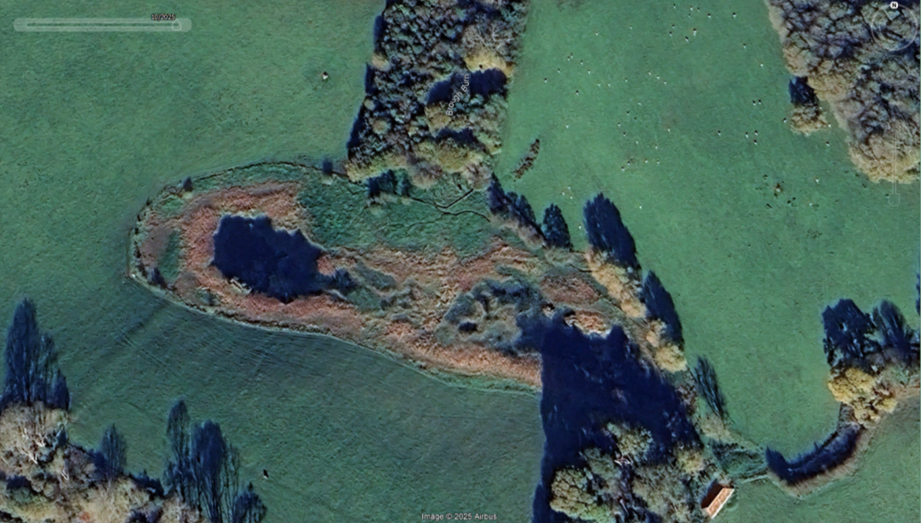
2025

White Loch
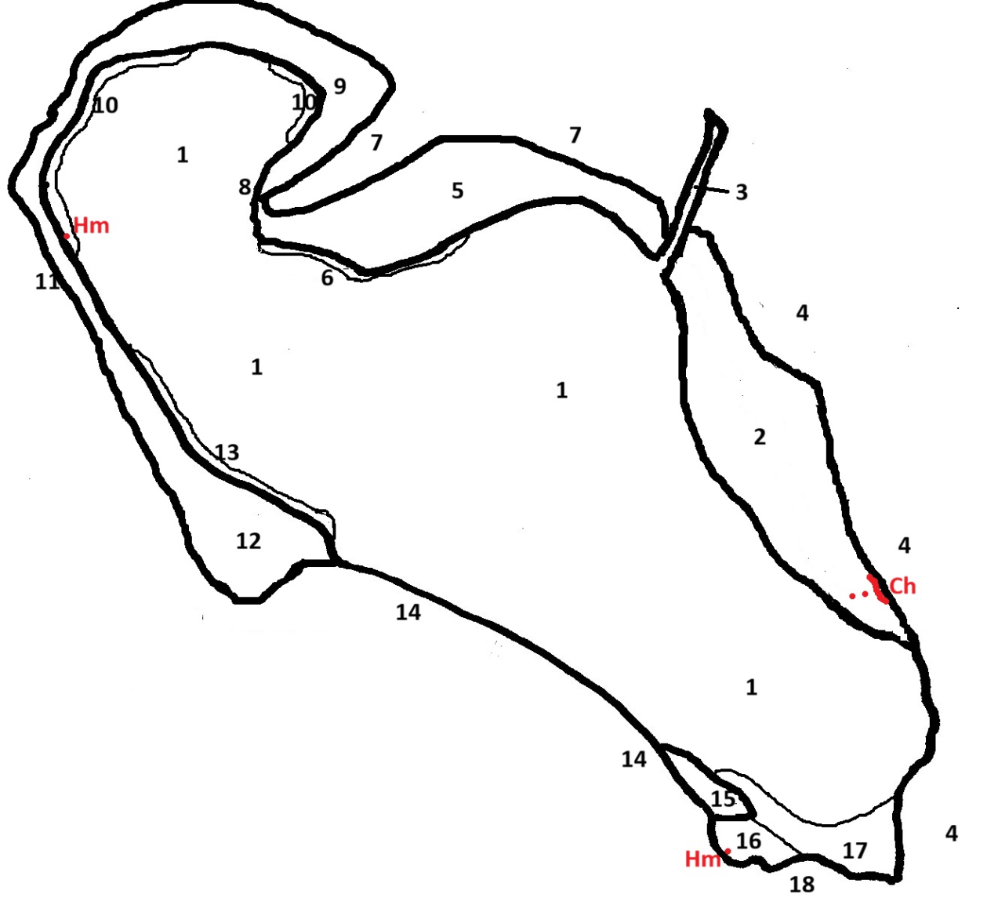
This is the largest of the Colvend lochs with an area of 13 hectares and a maximum depth of 13 metres. The water is tea-coloured and a secchi depth of 1.4 metres was recorded during the survey. A particular feature of this loch is the extensive swamp vegetation which seems to be actively spreading into the open water, particularly on the northern side, reaching 50 metres wide in places. The main species is Lesser Bulrush Typha angustifolia but there are also areas with Common Reed Phragmites australis, Common Club-rush Schoenoplectus lacustris and Bottle Sedge Carex rostrata and there are also a few patches of Branched Bur-reed Sparganium erectum at the south-eastern end. The swamp commonly extends out to depths of nearly two metres and outside this there is an intermittent band of Yellow Water Lily Nuphar lutea which in a few places reaches 10 metres wide.
Because of the strongly coloured water, the depths outside the swamp are too deep for submerged species and these are absent from most of the loch. A more diverse aquatic flora is therefore restricted to two places where the water is shallow enough for light penetration but not occupied by swamp or overshaded by trees. These are a bay in the southern corner and a boat channel leading to a house on the northern side. In the former there are Alternate Water Milfoil Myriophyllum alterniflorum, Curled Pondweed Potamogeton crispus and some patches of Willow Moss Fontinalis antipyretica. In the latter there are Alternate Water Milfoil Myriophyllum alterniflorum, Nuttall’s Waterweed Elodea nuttallii and a little Common Duckweed Lemna minor.
1 – Deep water unvegetated.
2 – Wide swamp to 50 metres wide. Common Reed Phragmites australis dominated on the landward side, Open Common Club-rush Schoenoplectus lacustris on lochward side. Water Horsetail Equisetum fluviatile and Lesser Bulrush Typha angustifolia mixed through both parts. Water to 60 cm deep within swamp but drops to 1.8 metres off the edge. A few Yellow Water Lily Nuphar lutea within the swamp and on the outer edge.
3 – Boat channel leading to house with vertical sides and mown grass above. In water, Yellow Water Lily Nuphar lutea and Alternate Water Milfoil Myriophyllum alterniflorum with a little Common Duckweed Lemna minor and Nuttall’s Waterweed Elodea nuttallii
4 – Mixture of woodland and gardens on slope above loch.
5 – Swamp, mainly Lesser Bulrush Typha angustifolia and Common Club-rush Schoenoplectus lacustris. To c. 50 metres wide.
6 – Sparse Yellow Water Lily Nuphar lutea.
7 – Swamp backed by willows, then woodland
8 – A few patches of Yellow Water Lily Nuphar lutea.
9 – Swamp, mainly Lesser Bulrush Typha angustifolia, up to 40 metres wide.
10 – Yellow Water Lily Nuphar lutea band, to 10 metres wide. Some blue-green algal bloom accumulated in this area.
11 – Swamp, mainly Lesser Bulrush Typha angustifolia backed by mixed woodland.
12 – As 11 but widening to 40 metres wide.
13 – Yellow Water Lily Nuphar lutea band to 10 metres wide.
14 – Trees overhanging edge. Bouldery at shore and bottom shelves steeply. No swamp.
15 – Lesser Bulrush Typha angustifolia swamp patch. Some cutting back by local resident.
16 – Small bay with frequent Curled Pondweed Potamogeton crispus and scattered Alternate Water-milfoil Myriophyllum alterniflorum.
17 – Patchy Yellow Water Lily Nuphar lutea in depths up to 2.8 metres. Some Willow Moss Fontinalis antipyretica patches
18 – Gardens adjacent and mostly protecting wall at shore. A few patches of Branched Bur-reed Sparganium erectum.
19 – Bouldery shore + some decking/slipway. A few patches of Branched Bur-reed Sparganium erectum
Hm – Frogbit Hydrocharis morsus-ranae. Loose strands caught in swamp or at margin.
Ch – New Zealand Pigmyweed Crassula helmsii. Mostly at landward edge of swamp but beginning to spread into the swamp.
Comment: Apart from water lilies (Yellow Water Lily Nuphar lutea) the aquatic vegetation is very limited in this loch. This is because of the strong humic colouring of the water and the extensive swamp occupying the shallower water zones where submerged aquatics would be expected. Some planktonic blue-green alga was observed in various places and there were accumulations in the north-western bay (which was down-wind during the survey) indicating that there are also nutrient issues. If algal blooms are a regular occurrence, this will also reduce light penetration for submerged species. White Loch is the best documented loch in the area historically in relation to the aquatic vegetation and this indicates a significant reduction in the diversity over the last 30 years with the losses particularly among nutrient-sensitive species.
The loch has very extensive areas of swamp communities. The main swamp species is Lesser Bulrush Typha angustifolia and although this is regarded as a species native to Britain, it is possible that it was originally introduced here. It was certainly well established over 100 years ago but at that time it seems to have been more restricted to the western side (West 1905).
The discovery of a patch of New Zealand Pigmyweed Crassula helmsii is concerning as this is an aggressive non-native species. It is currently restricted to an area within the swamp on the east side and at this point it might be possible to control it (but with some cost and effort). But once it spreads outside the swamp it is likely to spread quickly around the loch. In due course this could result in its further spread to other lochs in the system through fragments carried by birds or anglers. Some garden waste was observed dumped at the bottom of a garden close to the place it occurs and it may be that this is where it originated, perhaps from material cleared from an ornamental pond within the garden. The presence of Frogbit Hydrocharis morsus-ranae is also as an introduction but this is a benign species that is unlikely to cause problems. Also present is the non-native Nuttall’s Waterweed Elodea nuttallii in a boat channel on the north-eastern side. This seems to be limited only to this area and although it can be invasive, its spread may be limited here by the acidity of the water.

Appendix 3 - A composite species list for all sites
Species Abundance
This spreadsheet includes a measure of abundance for every species in each site, using the DAFOR system in which:
D=Dominant
A=Abundant
F=Frequent
O=Occasional
R=Rare.
These may be qualified by adding an ‘L’ to signify ‘locally’. Thus LD=Locally Dominant

Lake Macrophyte Nutrient Index (LMNI) scores
This is a crude measure of the nutrient status of a loch based on its aquatic species composition. It is one of the parameters used by SEPA when assessing the status of the vegetation of a loch. Each species has a score based on its nutrient tolerance the score for the loch is an average of these. The higher the score, the higher the nutrient status.

Barend comes out as the highest, as one would expect, but generally these are low figures, reflecting the acidic nature of the lochs in this area.

 | Duffs | Jennifer's | Fairgirth | Opposite Clonyard | Clonyard Loch | Clonyard pond | Barean | White | Black | Newbarns | Golf course 1 | Golf course 2 | Golf course 3 | Golf course 4 | Golf course 5 | Barend | Dumstinchall | Auchenskeoch | Southwick House | Southwick Lake | Dunmuck lower | Dunmuck upper
AQUATIC SPECIES
Aponogeton distachyos |  |  |  |  |  |  |  |  |  |  |  |  |  |  |  |  |  |  |  |  | ola
Callitriche brutia |  |  | r |  |  | r |  |  |  |  |  |  |  | r |  |  | o
Callitriche stagnalis |  | r | r | r | r |  |  |  |  |  |  |  | r | r | r
Ceratophyllum demersum |  |  |  |  |  |  |  |  |  |  |  |  |  |  |  | ald
Chara virgata |  |  |  |  |  |  | ola
Crassula helmsii |  |  |  |  |  |  |  | la
Eleocharis acicularis |  |  |  |  |  |  |  |  |  |  |  |  |  |  |  |  |  |  |  |  |  | a
Eleogiton fluitans |  |  |  |  |  |  |  |  |  |  |  |  |  |  |  |  |  |  |  |  |  | f
Elodea canadensis |  |  |  |  | olf |  | f
Elodea nuttallii |  |  | d |  |  |  |  | r |  |  |  |  |  |  |  | a |  | d | ald
Filamentous algae |  |  | f |  |  |  |  |  |  |  |  |  | f |  |  | a | o |  |  | f
Fontinalis antipyretica |  |  |  |  | fla |  |  | o |  |  |  |  |  |  |  |  | d
Helosciadium inundatum |  |  |  |  |  |  |  |  |  |  |  |  |  |  |  |  |  |  |  |  |  | a
Hydrocharis morsus-ranae |  |  |  |  |  |  |  | lf
Juncus bulbosus | o |  |  |  | r |  |  |  |  | o |  | r | f | f | o |  | o
Lemna minor | r | r | f | o | o | olf | o | r |  |  | r |  | r | o | o | o | o | r | o | f | o | o
Lemna minuta |  |  |  |  |  |  |  |  |  |  |  |  |  |  |  | a
Lemna trisulca |  |  |  |  |  |  |  |  |  |  |  |  |  |  |  |  | a | f
Littorella uniflora |  |  |  |  |  |  | r
Lythrum portula |  |  | r |  |  |  |  |  |  |  |  |  |  |  |  |  | r
Myriophyllum alterniflorum |  |  | f |  |  |  |  | o | la |  |  |  |  |  |  |  |  |  | r |  | f
Nitella flexilis agg. |  |  |  |  | o | fla | f |  |  |  |  |  |  |  |  |  |  |  |  | o
Nitella translucens |  |  |  |  |  |  | f |  | a
Nuphar lutea | a |  |  |  |  |  | a | lf | a | r |  |  |  |  |  | ola
Nymphaea alba | o |  |  |  |  |  | fla |  | f | a
Nymphaea cultivar |  |  |  |  |  |  |  |  |  |  | f |  |  |  |  | fla |  |  |  |  | r
Nymphoides peltata |  |  |  |  |  |  |  |  |  |  |  |  |  |  |  |  |  | olf | ald
Persicaria amphibia |  |  |  |  |  |  |  |  |  |  | r |  |  |  |  |  | a |  |  | olf |  | o
Potamogeton alpinus |  |  |  |  | o |  | f
Potamogeton berchtoldii |  |  | o |  |  |  |  |  |  |  |  | r | d | f |  | r
Potamogeton crispus |  |  |  |  |  |  |  | lf
Potamogeton natans |  | o |  | f | o | a | o | r | o |  | a | o | lf | a | f |  |  |  |  | ald | d | d
Potamogeton obtusifolius | r |  |  | r | olf | o | r |  |  |  |  |  |  | f | f | r
Potamogeton polygonifolius | r |  | o | o |  |  | r |  | o |  |  | r | r | f |  |  | o |  |  |  | a
Ranunculus aquatilis agg. |  |  |  |  |  |  |  |  |  |  |  |  |  |  |  |  |  |  |  |  |  | r
Sparganium emersum |  | r
Sparganium floating sp. |  |  | o |  | r |  | o |  |  |  |  | r | f |  | f |  | f | r |  | r |  | o
Sphagnum spp. |  |  |  |  |  |  |  |  | a | a |  | a | o
Utricularia minor |  |  |  |  |  |  |  |  | a
Utricularia vulgaris agg. |  |  |  |  |  |  | a
Lake LMNI scores | 5.8 | 6.4 | 5.3 | 5.8 | 5.6 | 5.9 | 5.3 | 5.9 | 4.0 | 4.9 | 7.1 | 3.8 | 5.1 | 5.3 | 5.8 | 7.5 | 5.4 | 7.4 | 6.0 | 6.7 | 5.7 | 6.1
WETLAND SPECIES
Achillea ptarmica | o |  | o |  | o
Agrostis canina |  |  |  |  | r |  | o |  |  | o
Agrostis stolonifera | f | a | a | a | o |  |  | f | o |  | f | a | a |  |  | f |  |  | f | f |  | f
Alisma plantago-aquatica | r |  | o |  | o |  |  | f |  |  |  |  |  |  |  |  | a |  |  |  | r | f
Alnus glutinosa | o |  |  | o | a |  | a | o |  |  | o |  |  |  | o | o | o | o |  |  | o
Alopecurus geniculatus | r |  | r |  | r
Angelica sylvestris | r |  | o |  | o | o | o | o | o | o | o |  |  | o | o | f | o | r |  |  | o | o
Athyrium felix-femina | o |  | r |  | o |  |  | o | f | o |  |  | r |  | r | o | o | o | o
Bambusoideae |  |  |  |  |  |  |  |  |  |  |  |  |  |  |  |  | ld
Betula pubescens | f |  |  | o | r |  | f |  | a | a
Bidens cernua |  |  |  |  |  |  |  |  |  |  |  |  |  |  |  |  |  |  |  |  |  | r
Bolboschoenus maritimus |  |  |  |  |  |  |  |  |  |  |  |  |  |  |  |  | r
Calliergonella cuspidata | o |  |  |  |  |  | f |  |  |  |  |  |  |  |  |  | f
Caltha palustris | r |  |  |  | o |  |  | o
Calystegia sepium |  |  |  |  |  |  |  |  |  |  |  |  |  |  |  | f |  |  | r
Cardamine flexuosa |  |  |  |  | o |  |  |  |  |  |  |  |  |  |  |  |  | r
Cardamine pratensis | o |  | r |  | o |  |  |  |  | o
Carex canescens | r |  |  |  |  |  | r
Carex demissa |  |  |  |  |  |  |  |  | o | o
Carex diandra |  |  |  |  |  |  |  |  | lf
Carex echinata |  |  |  |  | r |  |  |  | r | o
Carex hirta |  |  |  |  |  |  |  |  |  |  |  |  |  |  |  |  |  |  |  | o
Carex limosa |  |  |  |  |  |  |  |  | r
Carex nigra | o |  | o | a | o |  |  | o | o | o |  |  |  |  |  |  |  |  |  |  | o
Carex panicea |  |  | r |  |  |  |  |  | o
Carex paniculata |  |  |  |  |  |  |  |  |  |  |  |  |  |  |  |  | o
Carex pendula |  |  |  |  |  |  |  | o |  |  |  |  |  |  |  |  |  |  | r
Carex remota |  |  |  |  |  |  |  |  |  |  |  |  |  |  |  |  |  | r | r | o
Carex rostrata | f |  | r |  | a | a | a | a | a | a |  | r | r |  |  |  | a | fla |  |  | ola
Carum verticillatum | r |  |  |  |  |  |  |  | r
Chrysospelnium oppositifolium |  |  |  |  |  |  |  |  |  |  |  |  |  |  |  |  |  | f
Cirsium palustre | o |  | r |  | o |  | ola |  | o | o |  |  |  | r | r |  |  |  |  | r
Cladium mariscus |  |  |  |  | olf |  |  |  |  | fla
Comarum palustre | f | r |  | f | f | f | f | f | a | f |  |  |  |  |  | r | r | o
Deschampsia cespitosa | r |  |  |  | o |  |  |  | r | o |  |  |  |  |  | o | o
Drosera rotundifolia |  |  |  |  |  |  |  |  | r
Dryopteris dilatata | o |  |  |  | r |  | o |  | o | o |  |  |  |  |  |  | r
Eleocharis multicaulis |  |  |  | r |  |  |  |  | f | lf
Eleocharis palustris | r | fla | f | o | o |  |  | o |  | r |  | o | f | o |  | o | olf | r | r |  |  | a
Epilobium ciiatum |  | r |  | o |  |  |  |  | r |  |  |  |  |  |  |  | r
Epilobium obscurum |  | r | o |  | r |  |  | r |  |  |  |  |  | o |  | f | r |  |  | o |  | o
Epliobium hirsutum |  |  |  |  |  |  |  |  |  |  |  |  |  |  |  | o | r
Epliobium palustre | o |  |  |  | f |  |  |  | r | o |  |  |  |  |  |  |  | r |  |  | o | r
Equisetum fluviatile | fla |  |  |  | f |  | f | f | o | a |  |  |  | a |  |  | d |  |  |  | ald
Equisetum palustre |  |  |  |  |  |  | o |  |  | o
Eriophorum angustifolium | r |  |  |  |  |  |  |  | f
Filipendula ulmaria | o | r | f |  | f | a | o | o |  | o |  |  |  |  |  | o | f | f | f | f
Galium palustre | o | o | f | o | o |  | o | o | o | o |  | r | r | o |  |  | olf | o | r | r | o | o
Glyceria fluitans | o |  | f | o | o |  | o |  |  | o | f |  | o |  | f |  | f |  | r |  | o | f
Glyceria maxima |  |  |  |  |  |  |  |  |  |  |  |  |  | rlf |  |  |  |  |  | d
Hydrocotyle vulgaris | o |  | f | a | f | fla | o | o | a | o | f | f | f |  |  |  |  |  |  | o |  | a
Hypericum elodes |  |  |  |  |  |  | o |  | fla | lf | r
Iris pseudacorus | r | r |  | r | o |  |  | r |  |  |  |  |  | o |  | a |  |  | fla |  | r
Juncus acutiflorus | o |  | f |  | o | f | o |  | fla | o | a | f | f | f | o |  |  |  |  | o | o | o
Juncus articulatus |  |  | f | r | o |  | r |  |  | o |  |  |  | r |  |  | o |  |  | o
Juncus bufonius |  |  |  |  | r
Juncus conglomeratus |  |  |  |  |  |  |  |  |  | r
Juncus effusus | r | a | a | ald | o | o | o | o | r | o |  | o | o |  | o | o | rlf | f | r | o | f | a
Lotus pedunculatus | o | r | o |  | o | o |  |  | o | o | r | r | r | r | r | f | o | o |  |  | o
Lycopus europaeus | f | o |  |  | o |  |  | f | o | o |  |  |  |  |  |  | o
Lysichiton americanus |  |  |  |  |  |  |  | r
Lysimachia nummularia | la |  |  |  |  |  |  |  |  |  |  |  |  |  |  |  | r
Lysimachia vulgaris | o |  |  |  | o
Lythrum salicaria | o |  |  |  | o |  |  | f
Mentha aquatica | f |  | f |  | o | fla | o | f | o | o | r |  |  | f |  | f | f | o |  | f
Mentha x verticillata | o |  |  |  | o |  |  |  |  |  |  |  |  |  |  |  |  |  |  | o
Menyanthes trifoliata |  |  |  |  |  |  | fla |  | f | a |  |  |  |  |  |  | rlf |  | fla
Molinia caerulea | o |  |  |  | lf |  | o |  | o | o
Montia sibirica |  |  |  |  |  |  |  |  |  |  |  |  |  |  |  |  |  | r
Myosotis laxa | o |  | o |  | o |  | o | r | r |  |  |  | r | r |  |  | r | ?o |  |  | fla | r
Myosotis scorpioides |  |  |  |  |  |  |  | o |  |  |  |  |  |  |  |  |  |  |  |  |  | o
Myosotis secunda |  |  |  |  | r |  | 0 |  |  | r
Myrica gale | r |  |  |  | olf |  |  |  |  | o
Narthecium ossifragum |  |  |  |  |  |  |  |  | f
Nasturtium officinale agg. | o |  | o
Nasturtium officinale s.s. |  |  |  |  |  | olf
Oenanthe crocata |  |  |  |  | o |  |  |  |  |  | r |  |  | o |  | a |  | f |  | f
Osmunda regalis |  |  |  |  |  |  | r
Pedicularis palustris |  |  |  |  |  |  |  |  |  | r
Persicaria hydropiper | o | r | o | f | o |  |  |  |  |  |  |  |  |  |  |  |  |  |  |  |  | o
Phalaris arundinacea | f |  |  |  | o |  | o | lf |  |  |  |  |  |  |  |  | a | a | f | o
Phragmites australis | a |  |  |  | a |  | a | ald |  | a
Potentilla anserina | o |  | o | o | o |  |  |  |  |  | o |  |  |  |  |  |  |  |  |  |  | o
Ranunculus flammula | o | r | o | o | o | r | r | o | o | o | r |  | o |  | r |  | o |  |  |  | a | f
Ranunculus lingua |  |  |  |  |  |  |  |  |  |  |  |  |  |  |  | olf |  |  | a
Reynoutria japonica |  |  |  |  |  |  |  |  |  |  |  |  |  |  |  |  | o
Salix alba |  |  |  |  |  |  |  |  |  |  |  |  |  |  |  |  |  |  |  | o
Salix caprea |  |  |  |  |  |  | r |  |  |  |  |  |  |  |  |  | r
Salix cinerea | a |  | r | fla | a |  | a | lf | lf | a | a |  |  | o |  |  |  | ald |  | o | a
Salix x fragilis |  |  |  |  |  |  |  | o
Schoenoplectus lacustris | fla | r |  |  | a |  | a | a
Scutellaria galericulata |  |  |  |  | r |  | o
Senecio aquaticus |  |  |  |  | o |  |  |  |  |  |  |  |  |  |  |  |  |  |  | o
Silene flos-cuculi | o |  |  |  | o | o |  |  | o |  |  |  |  |  |  |  | r
Solanum dulcamara | o |  |  |  |  |  | r | o
Sorbus aucuparia |  |  |  |  | r
Sparganium erectum | o | fla | f | r | o | o | r | lf | r |  |  |  |  | o |  | r | f | f |  |  |  | o
Stachys palustris | o |  |  |  |  |  |  | o | r |  |  |  |  |  |  | f |  | r | o
Stellaria alsine |  |  |  | r | r |  |  |  |  |  |  |  |  |  |  |  | r |  |  |  |  | r
Succisa pratensis | o |  |  |  | r |  | o |  | o | o | lf | r |  | o
Triglochin palustris |  |  |  |  |  |  |  |  | r
Typha angustifolia |  |  |  |  |  |  |  | a
Typha latifolia | r |  | o |  | f | a |  |  |  |  |  |  |  |  | a |  | r |  |  | a | ola
Valeriana officinalis | o
Veronica beccabunga | o |  | f |  | r
Vicia cracca |  |  |  |  |  |  |  |  |  |  |  |  |  |  |  |  | r
Viola palustris | o |  |  |  | o |  | o |  | f | o | r

Appendix 4 - Comparison with historical records. Tables comparing aquatic species found in each of the main lochs with available historical records are set out below.

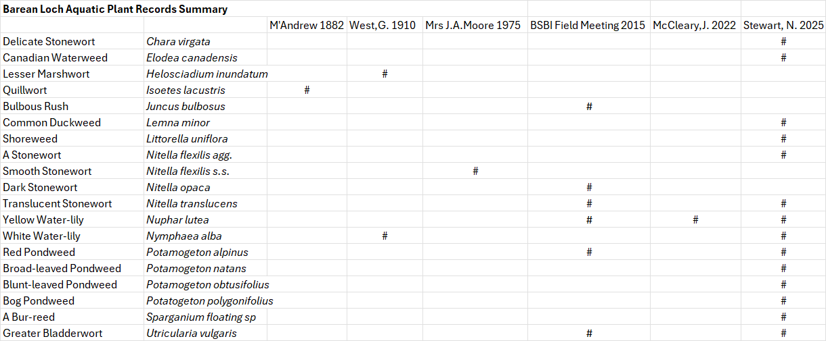

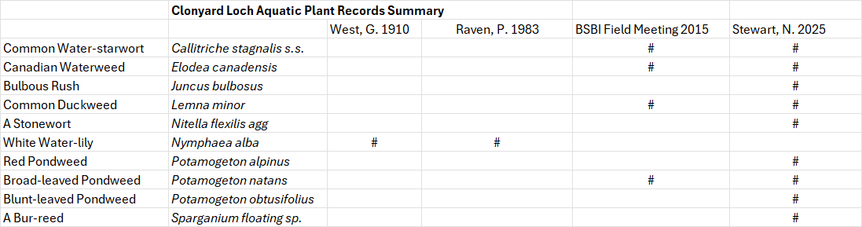

Lake Macrophyte Nutrient Index is one of the metrics used by SEPA when monitoring the status of vegetation in loch. It is a crude measure of the nutrient status of the loch as reflected by the vegetation with higher scores indicating higher nutrient levels. For further explanation of this metric see Appendix 3. The above graph reflects the change in nutrient changes in White Loch over the last 120 years.

