COLVEND AND SOUTHWICK COMMUNITY COUNCIL MEETING

Thursday 11 December 2025 at 7pm in Colvend Public Hall

PRESENT: Chair - Roderick Morriss (RM), Treasurer – John Rowland (JR), Secretary – Gordon Webster (GW); Elected CCs: John Coates (JC), Elspeth Collins-Taylor (ECT), Tom Nicol (TN); Co-opted CC: Matthew Pumphrey (MP); Kippford Association representative – David Butler (DB); Minute Secretary – Gwen Coates (GC)

MEMBERS OF THE PUBLIC: Sandyhills Protection Group (SPG) representative – Peter Shaw (PS), Sarah Gell (SG)

APOLOGIES: Elected CCs: Kristine Filer (KF), Tracy Roan (TR); Local Cllr: Ian Blake (IB), David Stitt (DS)

APPROVAL OF THE MINUTES OF THE PREVIOUS MEETINGS

Adoption of the Minutes from 6 November 2025

The minutes were proposed by ECT and seconded by JC. There were no amendments.

MATTERS ARISING FROM THE MINUTES

Residential development at Barnbarroch update. GW has been in touch with the local Planning Enforcement team and they agreed to send an inspector to site however they have also widened the scope to include NatureScot, SEPA and DGC Environmental Health. All correspondence has been shared with the resident who raised the matter to the CC. RM suggested that CSCC has done what it can. (GW/DS) This item is closed.

Dumfries and Galloway College youth opportunities engagement update. GW informed members of possible dates for a meeting the college had given him and requested a CC lead however there were no volunteers. JR suggested putting the issue on local WhatsApp group sites to ask if anyone is interested to take this further. GW agreed to do this and to let the college know that, in principle, there is interest but that CSCC will be seeking support from the local community to pursue this further. (GW)

Police Scotland livestock posters update. Clive Sinclair (local farmer) collected the posters that the police made available. He commented on their good quality but noted that of the six posters that were provided only four were of cattle and sheep. Councillor Ian Blake has been contacted to see if he can reengage with Police Scotland and elicit a further supply of suitable posters. (GW/CS)

Burma Bridge publicity update. It needs to be established if KF has taken responsibility for this item however, as she is ill at the moment, there is nothing further to report on this matter. GW/KF)

POLICE REPORT

The police report, sent to members before the meeting, noted that someone has been arrested and charged but it was not clear who, what or where the incident had taken place. GW agreed to publish this information on the local WhatsApp groups.

TREASURER'S REPORT

Prior to the meeting, JR sent members the following summary of transaction and noted that there had been no further transactions since those in October:

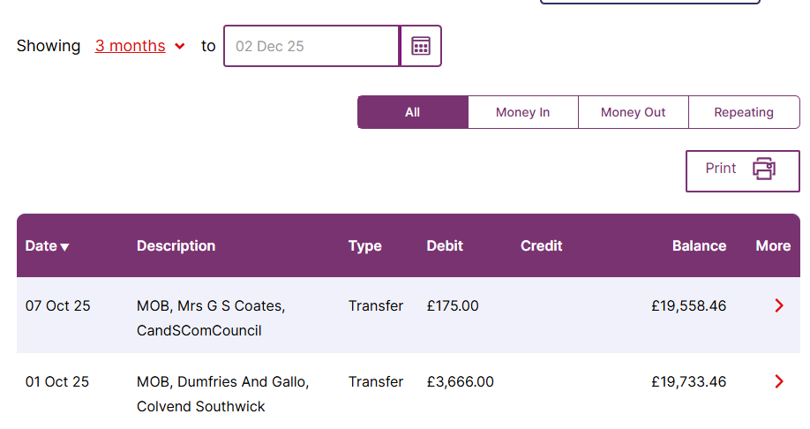

JR told members that he had been able to open an interest-bearing account and had transferred funds to this account. He suggested that he might be able to open a similar account for the Margaret Murdoch Trust funds. He told members that, because an application had not been made in time, there would be no funds from Dumfries and Galloway Council (DGC) for the 2026 Gala. However, he noted that a surplus from previous years was available to fund the event without the need for a DGC grant. GW suggested applying for funding from Dalbeattie Lions. There was some discussion about whether a Gala would take place in 2026 – this was returned to in the AOCB section.

FUTURE OF THE CRAB POT AT BAREND

SG, the owner of the Crab Pot at Barend explained that she was considering changing the premises to a community pub and wanted to discuss the idea with members. There was some discussion about how such a pub might be managed and staffed. SG noted that there are different options but, in general, a manager would have to be employed but that local volunteers might supplement any other staff requirements. She noted that approximately 25 of the lodges at Barend are lived in more or less permanently. She is keen to find out whether there might be sufficient interest in such a venture. She agreed to find out from the residents at Barend if they would be interested in the idea of such a pub. She suggested a Community Steering Group would need to be established and wondered if local people might wish to be involved in this and if CSCC would be prepared to assist and support the idea. It was agreed that once SG has checked on whether Barend residents might be interested, GW would put a note out on local WhatsApp groups to see if other local people might be interested.

PARCEL DELIVERY ISSUES

GW told members that this issue has been transferred to the Hall committee. A member of the Hall committee has made contact with a major delivery company to see if they could see a demand for having a parcel drop box installed at Colvend Public Hall from which people can collect their parcels.

WARM SPACE

JC said that the Margaret Murdoch Trust had rejected the request for funding for a ‘warm space’ because the purpose of funding did not match the remit of the trust. He went on to say that a meeting with the Resilience Group is to take place to discuss linking the idea of a warm hub to a resilience/emergency hub.

COLVEND PRIMARY SCHOOL

Mhairi Watkins has temporarily stepped down from her role as Primary School Parent Council representative but, prior to this had raised concerns with JR about the potential future closure of the school. Members suggested that it was likely that the school would remain open for at least 2 years.
Re swimming lessons, SG is the owner of the Barend pool and told members that a swimming teacher had been found. There was a discussion about the fact that currently children (of a certain age group only) go to the pool in Castle Douglas. SG suggested that, given the small number of pupils at Colvend Primary School, all pupils might be invited to the Barend pool. Currently plans are in place to hold swimming sessions there in August 2026. It was noted that DS has knowledge of the situation regarding lessons at Castle Douglas pool. He was not present at tonight’s meeting. JR suggested SG attend at the next meeting in February 2026 with updated plans so that these can be discussed with DS present.

PROJECTS

- Kippford Wee Pier renovation. JR has applied for grants and is awaiting outcomes. He suggested that if CSCC doesn’t get the Robin Rigg grant of £15,000 then the project cannot go ahead. He will know the outcome by the time of the next meeting in February 2026. DB said that the Kippford Association, at its AGM, had indicated community support for the wee pier. MP raised the issue about ownership. All interested parties (CSCC, Kippford Association, Solway Yacht Club) have indicated that they do not wish to take on the responsibility of ownership of the wee pier. MP said that he doesn’t feel that CSCC can repair something that it doesn’t own. There was some discussion about this among members. A positive letter has been received from the Crown Estates regarding the wee pier and mentioning an agreement with CSCC in order to undertake the necessary repair work. There was discussion about the terms of agreement the Crown Estates would accept. MP agreed to get in touch with them to establish the terms in such an agreement they would accept. This project is ongoing.

- Sandyhills to Colvend Footpath (previously active/safe travel on A710). As no one is showing interest in this at present, it was decided to remove this from future agendas. It was suggested that this might be passed to IB for him to see if DGC might take this forward. DS will be asked to suggest this to IB. This project is now closed.

- Portling and Southwick defibrillators(siting/installation/connection/training) update. GW is trying to arrange a date for a training session led by a Community First Responder. This project is ongoing.

- Kippford Flood Reduction measures. IB was not present at the meeting. He has confirmed that this is a DGC matter and will report at the next meeting. This project is ongoing.

- Disintegration of Visitor Interpretation Boards and Information Centre update. JR has taken one of the boards to Border Signs to be fixed and asked if others might take the rest in. This project is ongoing.

- Burma Bridge. See note under ‘Matters arising ...’. This project is ongoing.

COMMUNITY INVOLVEMENT

Winter Evening Talks programme update. JC gave details of the forthcoming talks in 2026, as follows: 16 January – Julian Stanning on a horticultural topic; 27 February – Sarah White on the Colvend Lochs Aquatic Survey; 20 March – Nick Chisholm on the Solway Coast and Marine Project (SCAMP). These details are to be put on the CSCC website and local WhatsApp groups. (JC) To be considered at the next meeting.

PLANNING APPLICATIONS

- 22/0197/SCO Scoping Opinion – paused awaiting applicant response.
- 23/1426/FUL Sandyhills proposed car park development – rolling agenda item.
- 23/2027/SCR Screening Opinion related to 23/1426/FUL: DGC Planning decision – No EIA required.

PS said that no updates were available and no further developments had taken place. The next planning application meeting is on 20 January 2026.

AOCB

- MP raised the issue of the Margaret Murdoch Trust. No further proposals for funding have been received. There was some discussion about whether the fund should be advertised on the CSCC website and/or local WhatsApp groups. There seems to be little evidence of people/groups in the area being ‘needy’ as required by the trust.

- JC raised the issue of the Gala in 2026. He said that some events are already being organised and noted that, given the next CSCC meeting is not until February 2026, the organising of events for the Gala will be well underway.

- MP raised the issue of organising a lunch in the new year and a provisional date of Sunday 18 January was decided.
- JR said that Simon Pain had a number of large boards and wondered if anyone might want these. It was noted that these might be useful to the local primary school.

OUR NEXT MEETING IS ON THURSDAY 5 FEBRUARY 2026

AT 7:00 PM IN COLVEND PUBLIC HALL

We encourage people who live in the area to attend these interesting meetings! Find out what is going on in your community.

www.colvendcommunity.co.uk

We also have a Facebook page & WhatsApp group!

If further copies of these minutes are required, please email secretary@colvendcommunity.co.uk

