COLVEND AND SOUTHWICK COMMUNITY COUNCIL MEETING

Thursday 11 September 2025 at 7pm in Colvend Public Hall

PRESENT: Chair - Roderick Morriss (RM), Treasurer – John Rowland (JR), Secretary – Gordon Webster (GW); Elected CCs: John Coates (JC), Kristine Filer (KF), Tom Nichol (TN), Tracy Roan (TR); Local Cllr: Ian Blake (IB); Kippford Association representative – David Butler (DB); Colvend Primary School Parent Council representative - Mhairi Watkins (MW);
Minute Secretary – Gwen Coates (GC)

MEMBERS OF THE PUBLIC: Maggie Nichols (MN)

APOLOGIES: Elected CC: Elspeth Collins-Taylor (ECT); Co-opted CC: Matthew Pumphrey (MP); Local Cllr: David Stitt

APPROVAL OF THE MINUTES OF THE PREVIOUS MEETINGS

Adoption of the Minutes from 3 July 2025

The minutes were proposed by JR and seconded by TN. There were no amendments.

MATTERS ARISING FROM THE MINUTES

  - ‘Warm Space’ funding from DGC update. JC said that he was hoping to get funding from the Margaret Murdoch Trust Fund and is currently pursuing this with the trustees of the Fund. To consider at the next meeting. (JC)

  - Chase more livestock posters from Police Scotland. GW said that Police Scotland had passed on their four remaining posters and would provide more next year if budgets allowed. Clive Sinclair is hoping to get the Dalbeattie Men’s Shed to replicate the posters and provide a robust backing board. There was some discussion about whether, for copyright purposes, the police logo would need to be removed. Further updates in Livestock 2025. (CS)

  - Interest-bearing bank accounts suitable for Community Councils. JR said that, after much research, he was to determine that such accounts were available because we were not a charity however he would be happy to hear from anyone else if they know differently. This item is closed.

  - Clarification of ownership of Community Council (CC) assets raised by DB. It was decided not to pursue this issue of asset ownership further. DB had initially raised this because he believed that the CSCC had a similar legal structure to the Kippford Association, which is not the case. CCs are not charitable bodies but operate under local authority regulations and structures. JR noted that that any assets that the CC owns, e.g. marquees, are not included in the CC’s Balance Sheet. This item is closed.

  - Overhanging trees on A710 near Colvend Golf Club. JC said that Scottish Water had attended to deal with a burst water pipe in the locality and, in doing so, have cut down the overhanging branches. This item is closed.

POLICE REPORT

The police report, sent to members before the meeting, noted that on 06.07.2025 there was a ‘theft by housebreaking at a domestic dwelling’. Enquiries are on-going.

TREASURER'S REPORT

Prior to the meeting, JR sent to members a summary of all transaction since the middle of May. There was a small shortfall of £75.39 in relation to the Gala day activities.
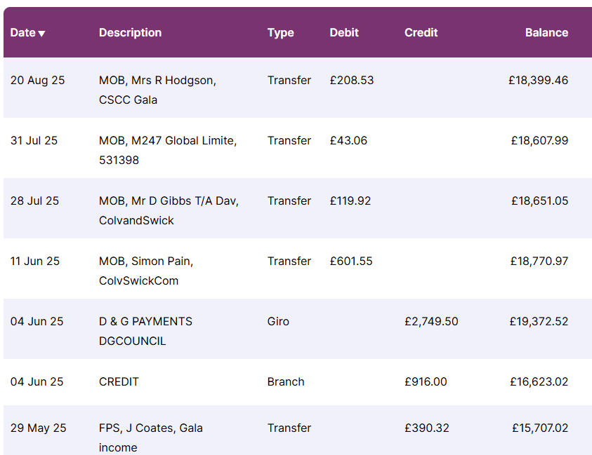

LIVESTOCK WATCH 2025

See point 2 under ‘Matters arising from the Minutes’ for information about posters. No further incidents of livestock worrying have been reported. To consider at the next meeting. (CS)

COLVEND PRIMARY SCHOOL

MW informed members that there are 12 children on the school roll this year. It is expected that there will be three new enrolments for the next school year but four children will be leaving at the end of this school year. This means that there is no guarantee that the school will remain open after this school year. There has been no further progress made in relation to swimming lessons. The school is keen to build links with the wider community and MW asked that anyone who had skills they might wish to offer should get in touch with the school.

PROJECTS

It was noted that, in the past, Simon Pain took responsibility for managing most of the projects that the CC was involved with. RM noted that it is unlikely that Simon can be replaced by a single person. RM said that, going forwards, anyone bringing a project to the CC for consideration will be expected to manage their project with support from the CC.

- Kippford Wee Pier renovation. DB noted that the pier was built in 1893, funded by public subscription and any work done on it since then was also by public subscription. CSCC has previously decided that it did not wish to adopt the pier. It has been said that residents of Kippford are no longer interested in funding the pier from public subscription. JR noted that neither the Kippford Association nor Solway (Kippford) Yacht Club wish to take ownership of the pier. RM questioned that, if this is the case, why is CSCC pursuing this? Three quotes are required before funding applications can be made for the necessary repair and renovation work. The feasibility study cost approximately £1,500 and if it is decided not to pursue the renovation, this sum would need to be reimbursed. This project is ongoing.

- Sandyhills to Colvend Footpath (previously active/safer travel on A710). This project is on hold until CSCC can get someone to fund a feasibility study. This project is ongoing.

- Portling and Southwick defibrillators (siting/installation/connection/training). JR said that the Portling defibrillator is now ‘up and running’. It doesn’t yet have child appropriate pads but these are to be supplied by the local First Responders group. There is no information yet about funding for the defibrillator at Southwick however, funding for a solar powered cabinet (to power the defibrillator) has been applied for.. This project is ongoing.

- Replacement Burma Bridge for Colvend School. This has been installed and is in use by children at the school. JR said that this has yet to be paid for. CSCC is awaiting the bill from the Dumfries and Galloway Council (DGC). This item is closed.

- Resilience Equipment. JC said that this and the ‘Warm Space’ funding are closely linked and it makes sense to pursue both at the same time. See item 1 in ‘Matters arising from the Minutes’. (JC) This project is ongoing.

- Kippford Flood Reduction measure. RM said it was important to note that the flood reduction project is completely separate from the Wee Pier project. IB said that Kippford flood reduction was a long-standing issue and agreed to contact the Flood Protection team at DGC to get an update on this. This project is ongoing.

- Disintegration of Visitor Interpretation Boards and Information Centre. JR said that Border Signs have agreed to replace the Visitor Interpretation backing boards free of charge because it realised that sub-standard material had been supplied. CSCC is thus awaiting further contact from the company. In the Information Centre, some of the panels have started to delaminate and temporary repairs have been made to a few. With the onset of Winter more work will be required before the delamination becomes serious. Also, the video is no longer working however exactly how to access the video player is quite complicated and will need on site guidance from Simon Pain. ECT has agreed to take over responsibility for leaflets in the Information Centre. This project is ongoing.

- Colvend Lochs Aquatic Plant survey. JR is optimistic that money will be in the bank to pay for this survey when it takes place. This project is ongoing.

COMMUNITY INVOLVEMENT

Winter Evening Talks programme. JC is working on this and will, hopefully, be able to present the completed programme at the next meeting. GW asked for clarification on whether these talks were a CC or Hall Committee event and JC confirmed that it was entirely the Hall Committee. RM had a recommendation to make, which he communicated to JC after the meeting. (JC) To be considered at the next meeting.

PLANNING APPLICATIONS

- 22/0197/SCO Scoping Opinion – paused awaiting applicant response.
- 23/1426/FUL Sandyhills proposed car park development – rolling agenda item.
- 23/2027/SCR Screening Opinion related to 23/1426/FUL: DGC Planning decision – No EIA response
Peter Shaw, representing Sandyhills Protection Group (SPG) was not present at the meeting. GW said that there was no update on the DGC planning website. The agenda for the next DGC planning committee is due out on 17 September 2025, suggesting their next meeting is likely to be the following week. GW had sent a letter to the planning authorities asking them to explain their decision not to require an Environmental Impact Assessment in relation to the Screening Opinion. He requested a response in time for tonight’s meeting but heard nothing back from them. He agreed to ‘chase them up’ tomorrow regarding this and if still no response to escalate the matter further.
- Local Place Plan (LPP). The completed LPP was submitted and accepted by DGC. This item is now closed.

AOCB

- RM noted the immense contribution that Simon Pain has made to CSCC over the years. He took on multiple roles as Vice Chair, fund raiser, project manager to name but a few. His enthusiasm, involvement and expertise will be greatly missed by members and by the local community.
- JC raised the following issues:
- Holes are already appearing in the newly resurfaced part of the road between the church and the Rockcliffe road end. IB said that he would raise this with DGC.
- Local road closure notices are not specific enough. They give no indication of when along a particular road the road closure is likely to be, which means that road users have no idea when to take an alternative route. IB said that he would raise this with DGC.
- The £250,000 to be spent on investigating bus transport issues in the region seems a lot of money to spend at a time when bus transport is being cut. IB noted that a lot of bus routes are under-used, many are subsidised and contractual issues with private bus companies have been problematic. As a result, DGC judge it necessary to spend this amount with the expectation the issues can be resolved or at least improved.
- TN commented on the success of the Quiz Night held recently at Colvend Public Hall. Note, this was not a CSCC event but an event put on by members of the Colvend Public Hall Committee. They gave thanks to the owners of Bainloch Deer Park who generously contributed prizes for the night and to the quiz master who contributed his time voluntarily.
- RM gave thanks to whoever the individual(s) was/were who strimmed the local path along the Rockcliffe road leading to the kirk from the junction and cut back the gorse on the coastal path.

OUR NEXT MEETING IS ON THURSDAY 2 OCTOBER 2025

AT 7:00 PM IN COLVEND PUBLIC HALL

We encourage people who live in the area to attend these interesting meetings! Find out what is going on in your community.

www.colvendcommunity.co.uk

We also have a Facebook page & WhatsApp group!

If further copies of these minutes are required, please email secretary@colvendcommunity.co.uk

